Attempt 2

All questions

Top of Form

Question 1: **Correct**

**Which of the following are true about Dashboards in Tableau?**

* 

**A bar chart can be used a floating item**

**(Correct)**

* 

**Tiled items don't overlap**

**(Correct)**

* 

**Floating items can be layered over other objects**

**(Correct)**

* 

**None of these**

**Explanation**

**From the official Tableau documentation:**

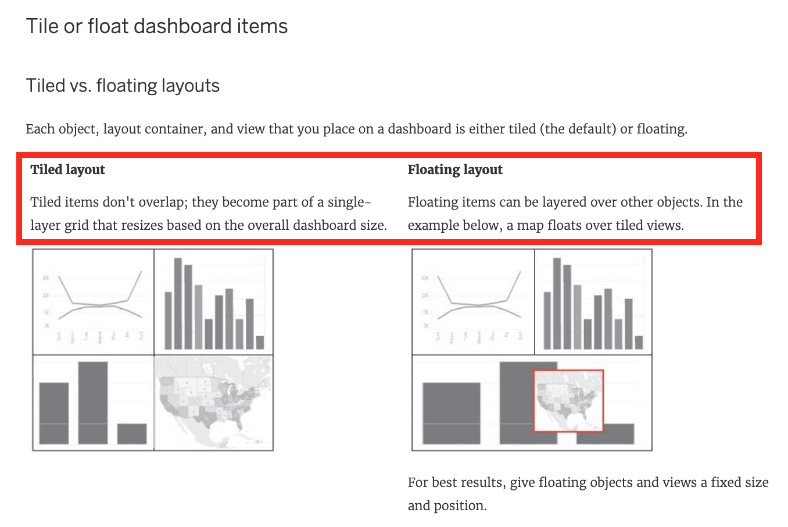

As we can see below, Bar charts can be used as a floating object.

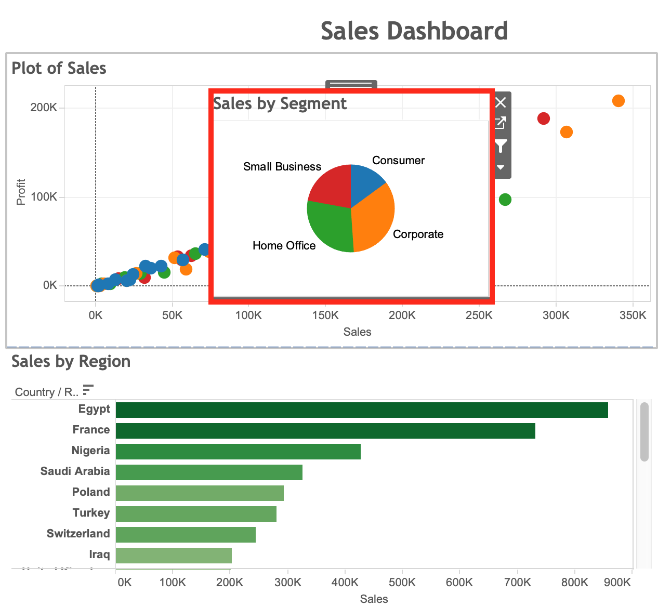

**Reference:** <https://help.tableau.com/current/pro/desktop/en-us/dashboards_organize_floatingandtiled.htm>

Bottom of Form

Top of Form

Question 2: **Correct**

**Which of the following are valid Dashboard size options?**

* 

**Fixed Size**

**(Correct)**

* 

**Scaled**

* 

**Automatic**

**(Correct)**

* 

**Range**

**(Correct)**

**Explanation**

Scaled is **NOT** a valid size options when creating Dashboards in Tableau!

After you create a dashboard, you might need to resize and reorganize it to work better for your users.

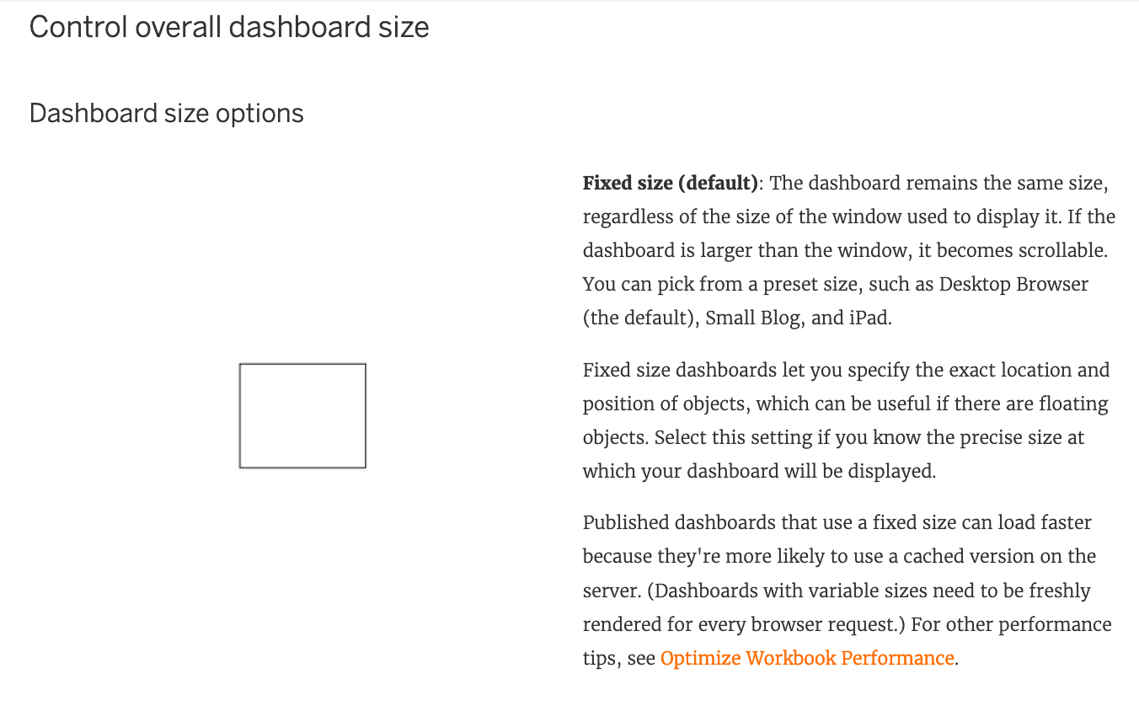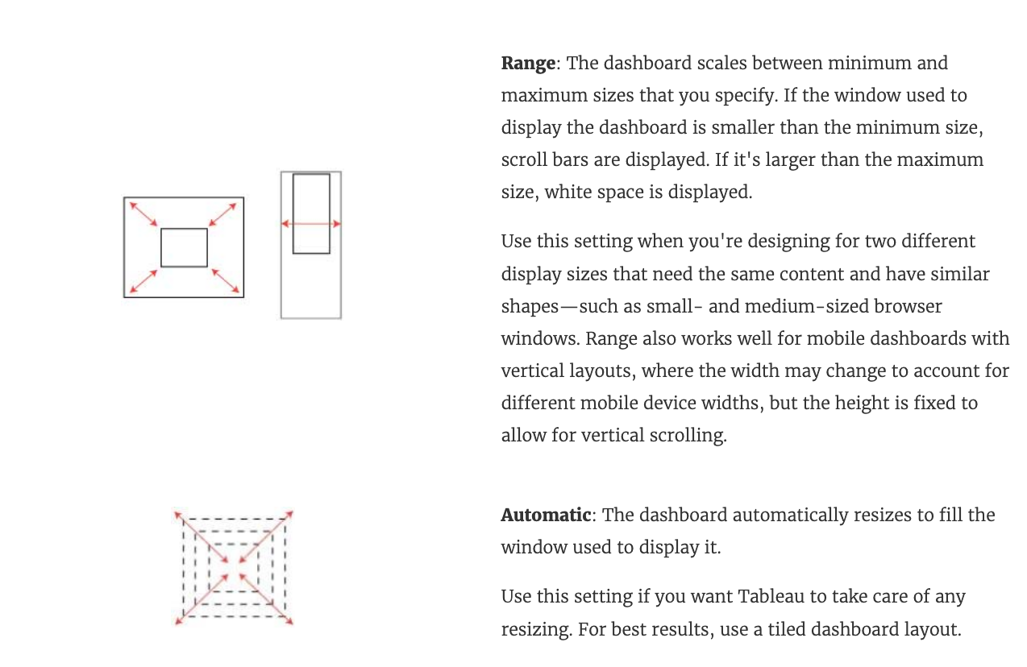

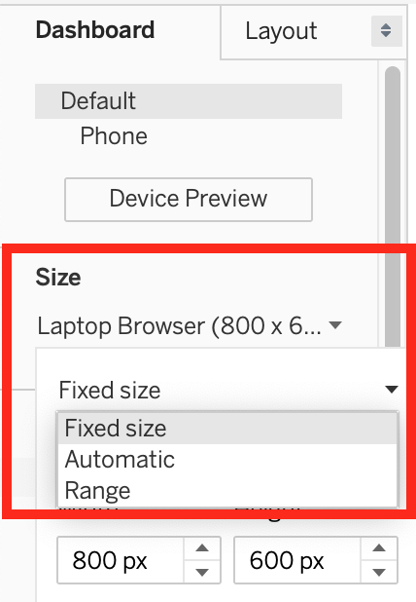

**Reference:**<https://help.tableau.com/current/pro/desktop/en-us/dashboards_organize_floatingandtiled.htm>

Bottom of Form

Top of Form

Question 3: **Incorrect**

**Which of the following sets would you use to compare the members?**

* 

**Dynamic Sets**

* 

**None of these**

* 

**Static Sets**

**(Incorrect)**

* 

**Combined Sets**

**(Correct)**

**Explanation**

You can combine two sets to compare the members. When you combine sets you create a new set containing either the combination of all members, just the members that exist in both, or members that exist in one set but not the other.

Combining sets allows you to answer complex questions and compare cohorts of your data. For example, to determine the percentage of customers who purchased both last year and this year, you can combine two sets containing the customers from each year and return only the customers that exist in both sets.

**To combine two sets, they must be based on the same dimensions. That is, you can combine a set containing the top customers with another set containing the customers that purchased last year. However, you cannot combine the top customers set with a top products set.**

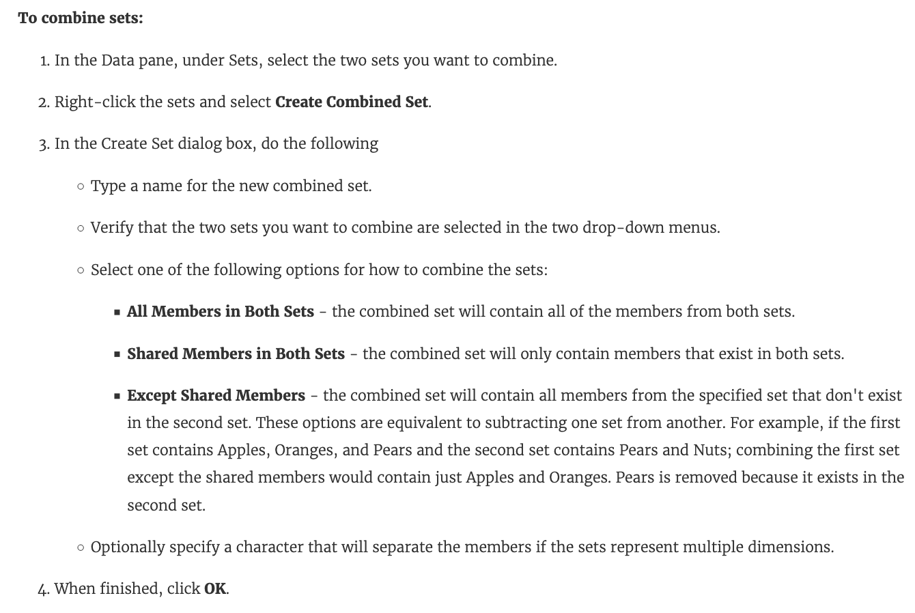

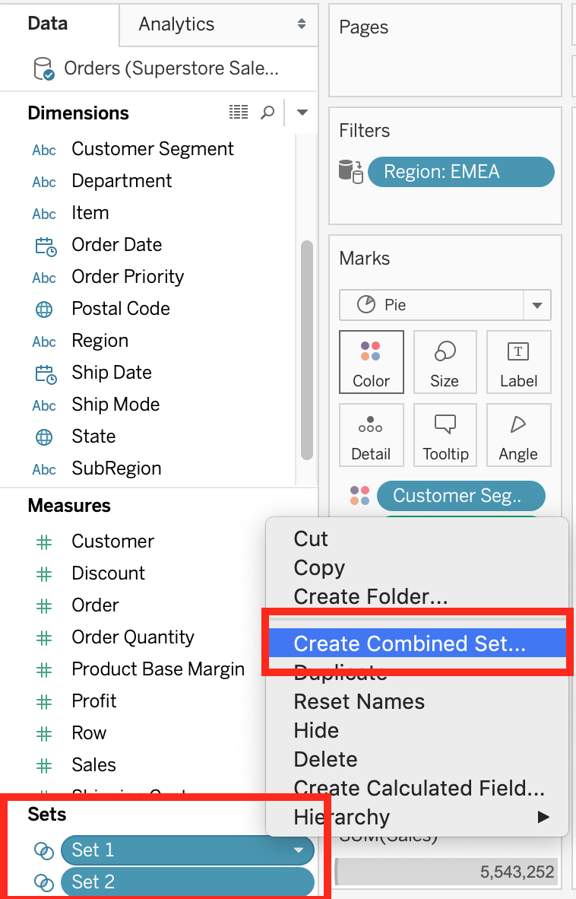

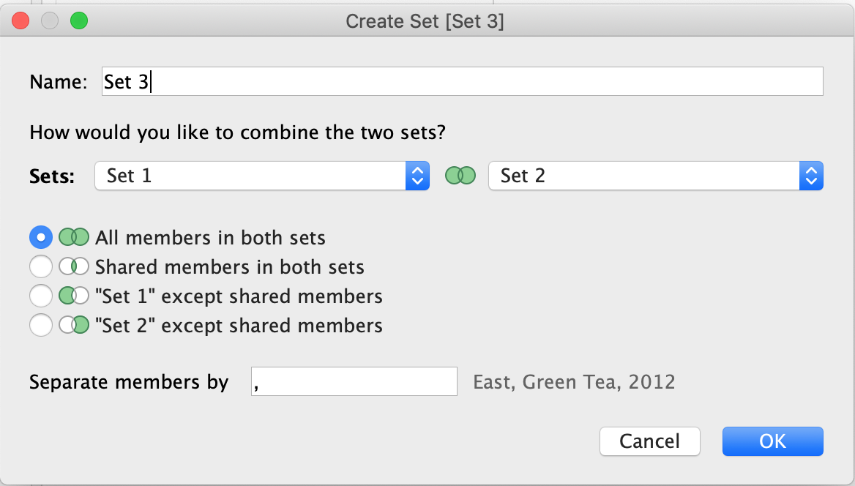

**Reference:** <https://help.tableau.com/current/pro/desktop/en-us/sortgroup_sets_create.htm>

Bottom of Form

Top of Form

Question 4: **Correct**

**True or False: Physical tables remain distinct (normalized), not merged in the data source whereas logical tables are merged into a single, flat table.**

* 

**True**

* 

**False**

**(Correct)**

**Explanation**

**In fact, the opposite of this is true.**

**Trick :** Whenever you think of joins -> Think that after the join is created, we get 1 single flat combined (joined) table. This flat combined table is created prior to us creating our visualizations. This happens at the physical layer.

If you ever think about relationships, know that all tables will remain distinct and separate, and relationships sit at the logical layer. At run time, when you bring in the dimensions and measures to create your viz, Tableau very smartly creates the necessary joins, relates the tables and sends queries to these tables to get the resultant data back in the most meaningful way possible. This allows you to focus on using your data and revealing insights from it and focus less on the data preparation aspect!

**Refer to logical layer vs physical layer from the official documentation:**<https://help.tableau.com/current/server/en-us/datasource_datamodel.htm>

Bottom of Form

Top of Form

Question 5: **Correct**

**Which of the following lets you *group related dashboard items together so you can quickly position them?***

* 

**Layout Blanks**

* 

**Layout Extensions**

* 

**Layout Containers**

**(Correct)**

* 

**Layout Positioners**

**Explanation**

**Layout containers** let you group related dashboard items together so you can quickly position them. As you change the size and placement of items inside a container, other container items automatically adjust

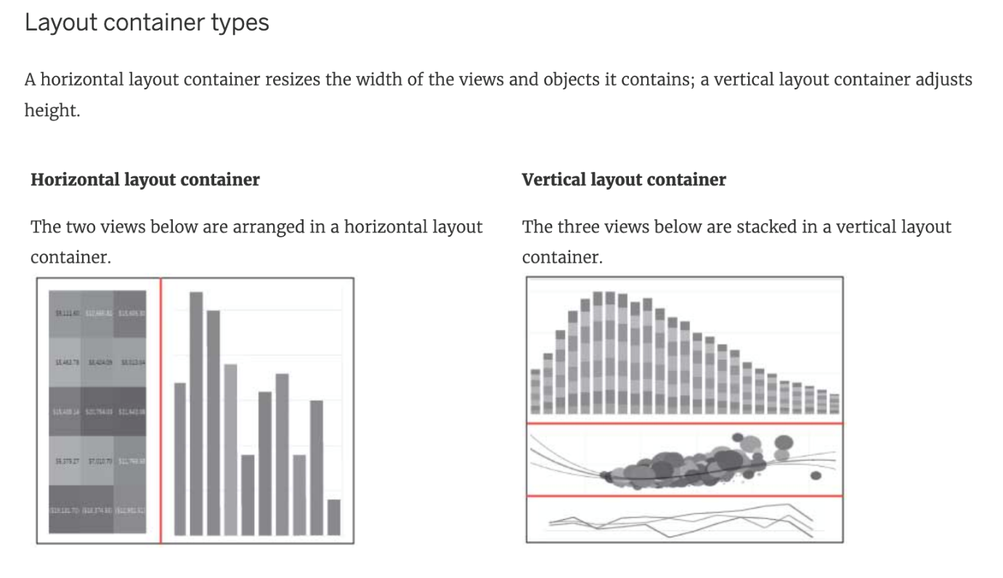

**Reference:**<https://help.tableau.com/current/pro/desktop/en-us/dashboards_organize_floatingandtiled.htm>

Bottom of Form

Top of Form

Question 6: **Correct**

**When is an axis created for the visualisation in Tableau?**

* 

**When we drag a dimension to the row/column shelf**

* 

**When we drag a continuous field to the row/column shelf**

**(Correct)**

* 

**When we drag a discrete field to the row/column shelf**

* 

**When we drag a measure to the row/column shelf**

**Explanation**

An Individual Axis in Tableau is obtained by adding a continuous into Rows or Columns Shelf.

Example:

In order to show Individual Axis in Tableau First, we drag and drop the Color from Dimension shelf to Column Shelf. Next, we drag and drop the Sales Amount from measures shelf to Rows Shelf. Since it is a continuous value, the Sales Amount will be aggregated to default Sum. Once you drag them, following Chart report will be generated.

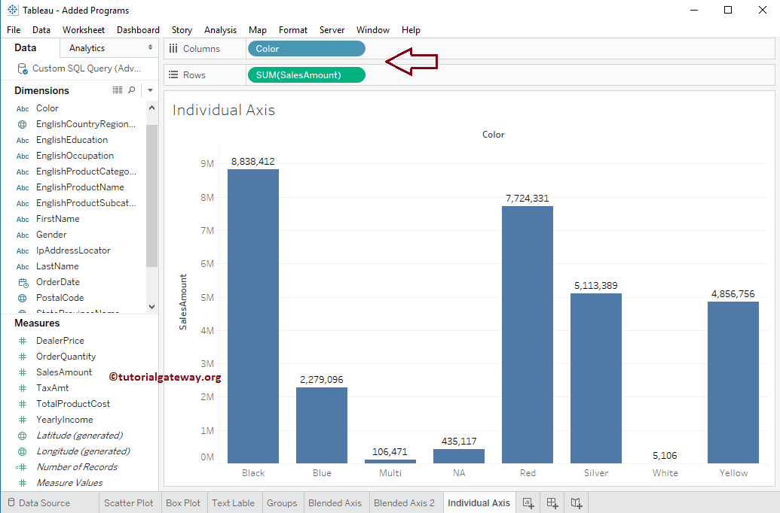

Next, we drag and Drop one more measure value, i.e., Total Product Cost from Measures Region to Rows Shelf. Because it is a Measure value, Total Product Cost is aggregated to default Sum. From the below screenshot, you can observe that Tableau has created an individual axis for each measure (continuous field).

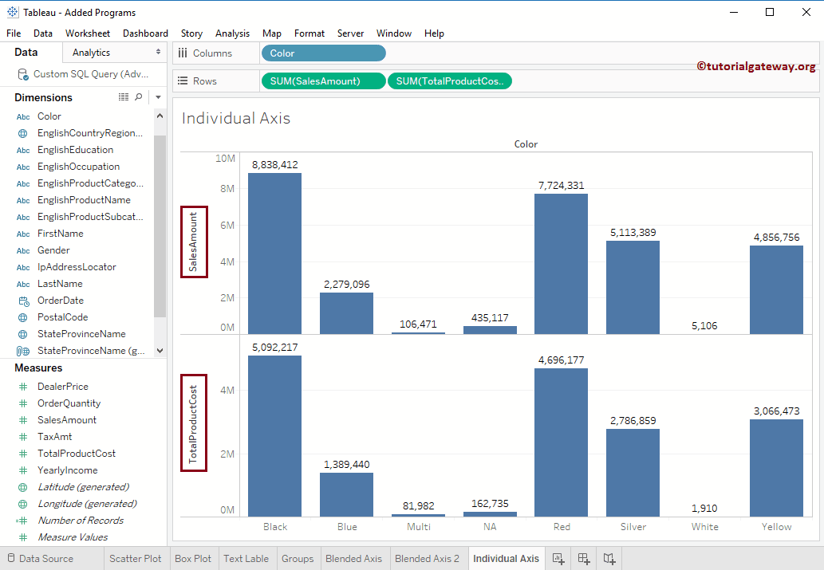

**Reference:**<https://www.tutorialgateway.org/individual-axis-in-tableau/>

Bottom of Form

Top of Form

Question 7: **Correct**

**A Tableau Data Source File (.tds) contains which of the following?**

* 

**Calculated Fields**

**(Correct)**

* 

**Copy of any local file-based data**

* 

**Default Field Properties**

**(Correct)**

* 

**Data Source Type**

**(Correct)**

**Explanation**

All are correct, except - Copy of any local file-based data. This is contained in a .tdsx file (Tableau Packaged Data Source)!

**According to the official documentation -**

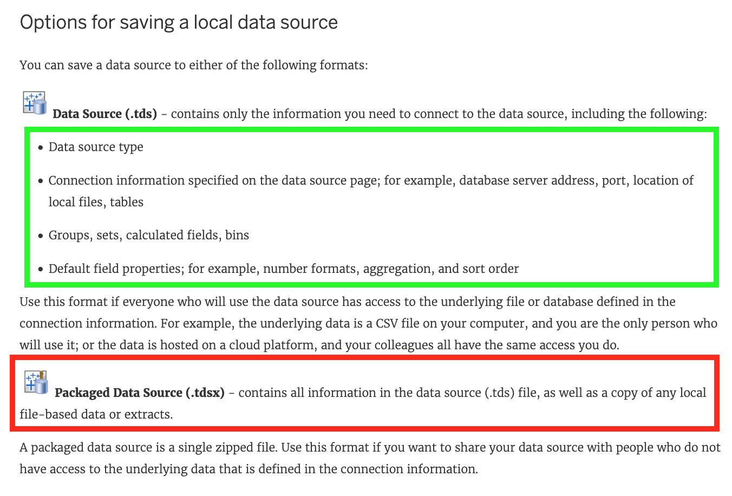

**Reference:**<https://help.tableau.com/current/pro/desktop/en-us/export_connection.htm>

Bottom of Form

Top of Form

Question 8: **Incorrect**

**When there are both negative and positive values for a field, the default range of values will use two color ranges. This is known as a ______________ palette.**

* 

**stepped**

**(Incorrect)**

* 

**diverging**

**(Correct)**

* 

**converging**

* 

**reversed**

**Explanation**

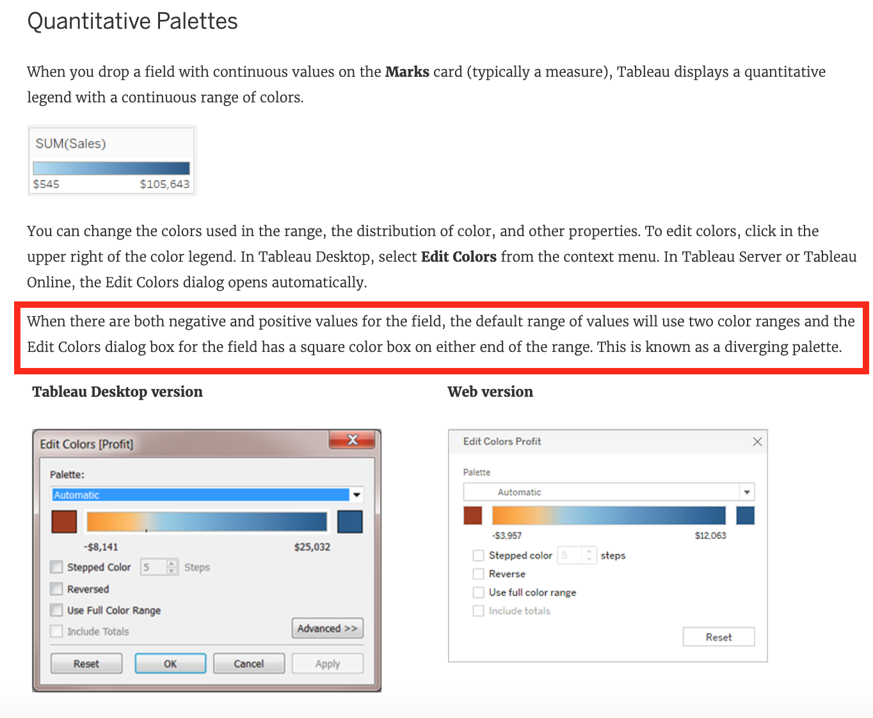

**Reference:** <https://help.tableau.com/current/pro/desktop/en-us/viewparts_marks_markproperties_color.htm>

Bottom of Form

Top of Form

Question 9: **Correct**

**Which of the following are valid reasons to use a Tableau Data Extract (.tde) over Live Connections?**

* 

**Help improve performance**

**(Correct)**

* 

**To support additional functionality such as count distinct**

**(Correct)**

* 

**To have access to the freshest possible data at all times**

* 

**Fast to create**

**(Correct)**

**Explanation**

From the official documentation, the following are the major advantages of using Tableau Data Extracts:

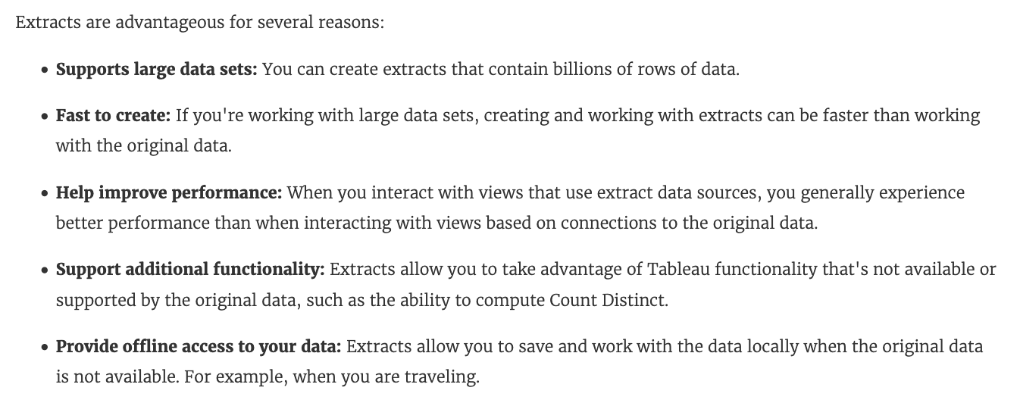

From Tableau 2020.2 onwards, .hyper is the recommended way since it is faster than .tde!

**Reference:** <https://help.tableau.com/current/pro/desktop/en-us/extracting_data.htm>

Bottom of Form

Top of Form

Question 10: **Correct**

**Which of the following are valid ways to make the font more readable in Tableau?**

* 

**Increase the font size**

**(Correct)**

* 

**Make the Font color sharper / darker than the background**

**(Correct)**

* 

**Decrease the font size**

* 

**Use a clear and readable font**

**(Correct)**

* 

**Don't use backgrounds**

**Explanation**

This is one of the most common questions on the Tableau Desktop Specialist Exam.

**Wrong options -**

**1) Don't use backgrounds -** This is not a solution. What if we want to use backgrounds? We can't just stop using backgrounds to solve this problem.

**2) Decrease the font size -** Do you think using a smaller font will make the text more readable? No right? Hence, this is wrong too.

**All other options are ways recommended to make your text more readable!**

Bottom of Form

Top of Form

Question 11: **Incorrect**

**Which of the following are valid ways to italicize Tooltip content in Tableau?**

* 

**Click on Format in the Menu bar, choose Font, and then edit the Tooltip options to italicize the font**

**(Correct)**

* 

**Click on Dashboard in the Menu bar, select Tooltip, and then use the italics option**

**(Incorrect)**

* 

**Click on Worksheet in the Menu bar, select Tooltip, and then use the italics option**

**(Correct)**

* 

**Click on Tooltip in the Marks card, select the text, and then use the Italics option**

**(Correct)**

**Explanation**

The only incorrect option is - Click on Dashboard in the Menu bar, select Tooltip, and then use the italics option.

This option doesn't exist. See below:

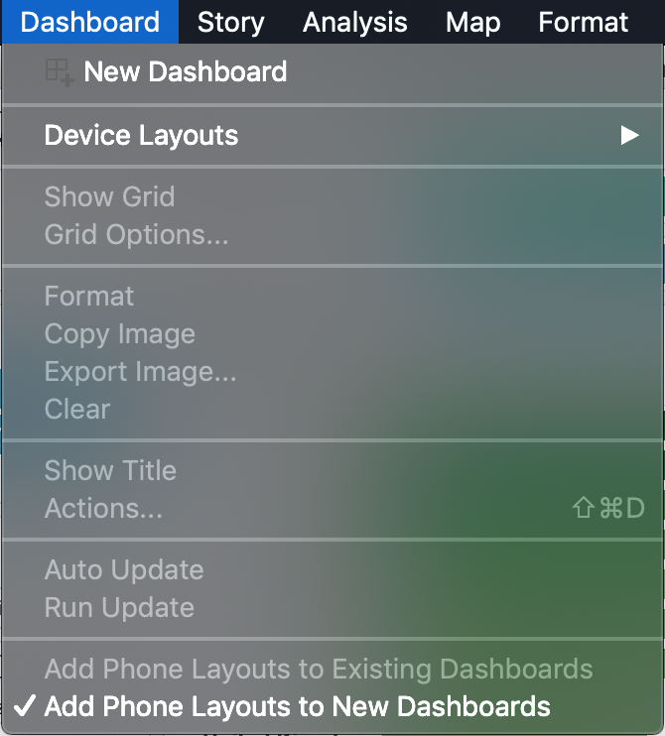

**The rest of the options do exist, and therefore are correct:**

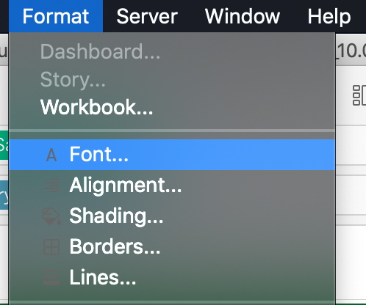

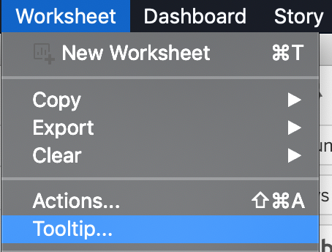

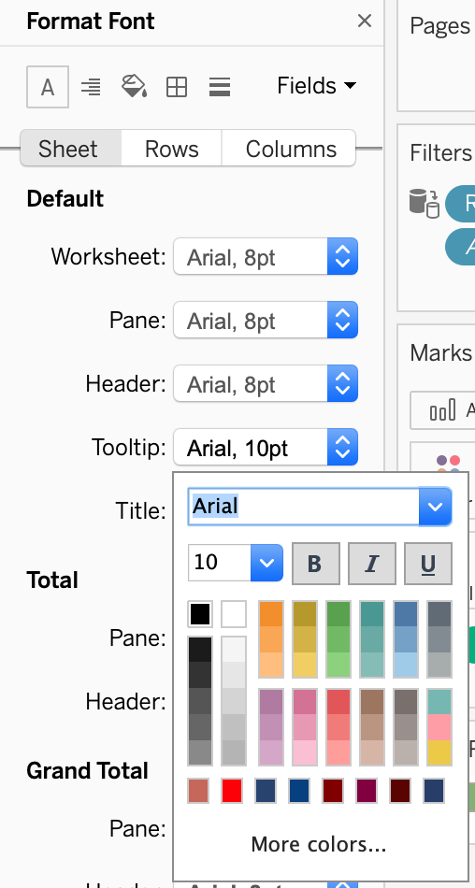

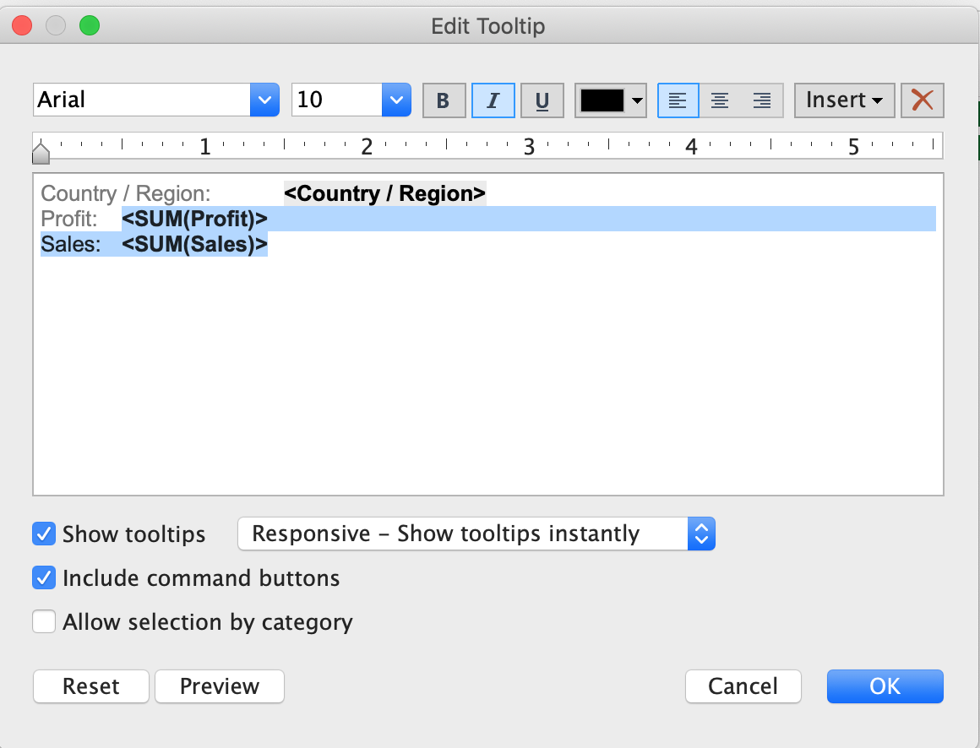

Bottom of Form

Top of Form

Question 12: **Correct**

**Which of the following describes the best way to change the formatting at a *workbook* level?**

* 

**It is only possible to specify formatting at a worksheet level, not at the workbook level.**

* 

**Click on Text in the Marks card, choose format, and then specify the formatting in the new Format workbook pane.**

* 

**Choose Format from the menu on top and then specify the formatting in the new Format workbook pane.**

**(Correct)**

* 

**Right click anywhere in the view, choose format, and then specify the formatting in the new Format workbook pane.**

**Explanation**

**Imp question:**

It is very much possible to specify the formatting at a **WORKBOOK** level (all sheets) instead of a single worksheet level.

You can quickly change how fonts, titles, and lines look in every view in a workbook by specifying format settings at the workbook level, instead of the worksheet level.

For example, you might want to use a specific font, size, and color so that all views adhere to your company's brand. You might also want to remove grid lines from your views—or make them more noticeable by increasing their pixel size or color.

You can also change the theme used by your workbook. Themes control items like the default font, colors, and line thickness. When you create a new workbook, it automatically uses the Default theme, which uses visual best practices.

**Change fonts in your workbook:**

You can change all fonts in your workbook or you can change fonts for only certain areas, such as just worksheet titles.

1) On the Format menu, select Workbook.

2) The Format Workbook pane replaces the Data pane on the left and provides a series of drop-down lists where you can change all font settings in a workbook, as well as the font settings for titles of worksheets, stories, and dashboards.

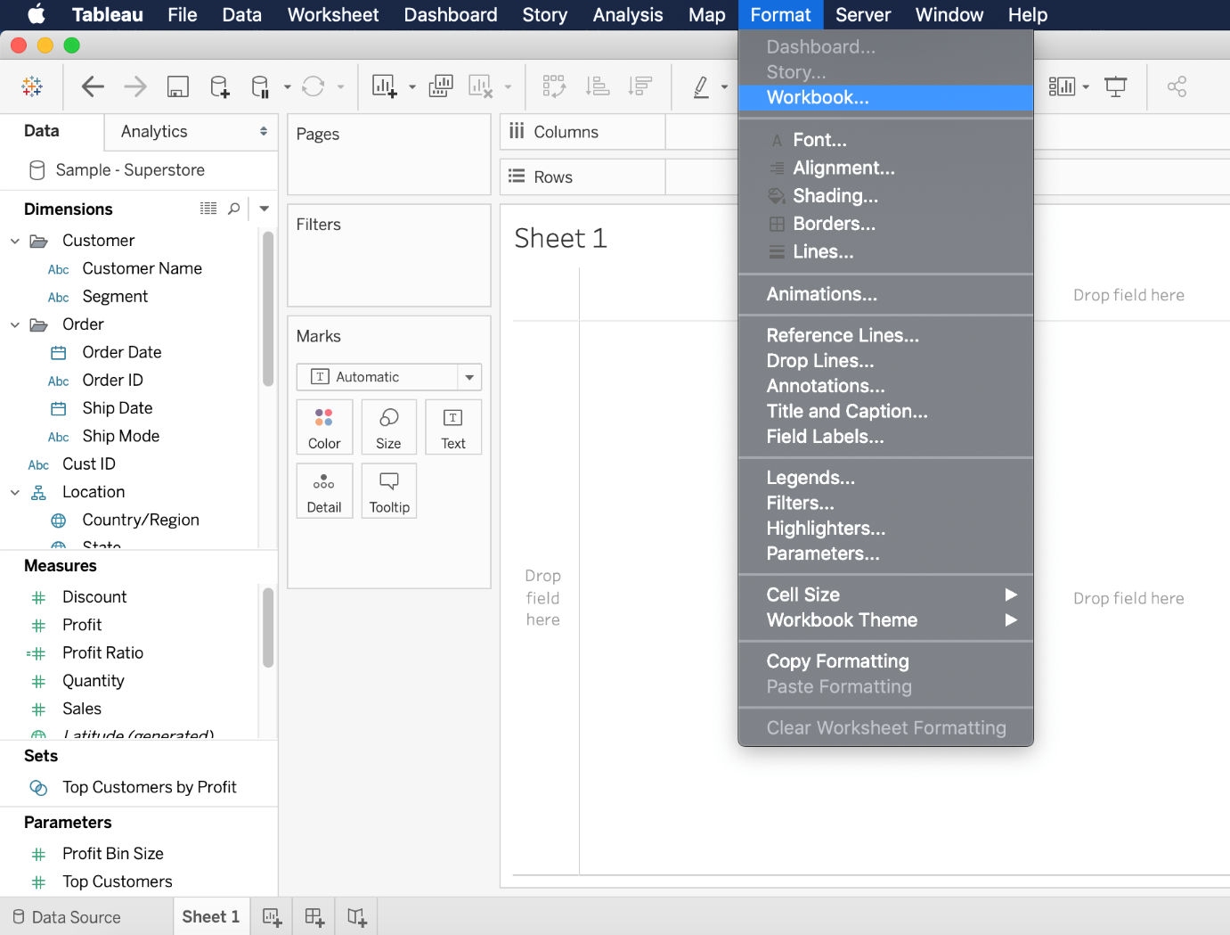

**Note: If you have made font changes at the worksheet level, such as on a filter card or a worksheet title, changing the font at the WORKBOOK level will overwrite those changes.**

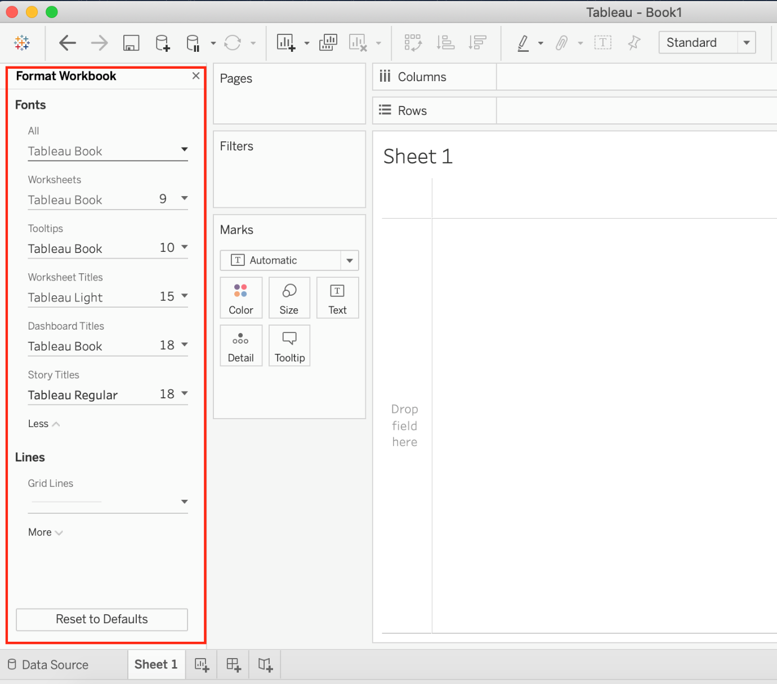

**Reset a workbook to its default settings**

When you make changes to your workbook's font settings, a gray dot appears next to the setting in the Format Workbook pane. You can quickly switch back to default settings using the Reset to Defaults button.

1) On the Format menu, select Workbook.

2) In the Format Workbook pane, click Reset to Defaults.

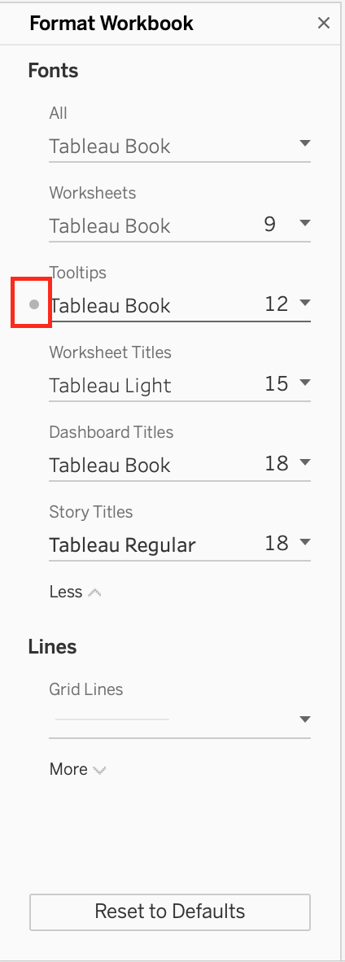

**Reference:**<https://help.tableau.com/current/pro/desktop/en-us/formatting_workbook.htm>

Bottom of Form

Top of Form

Question 13: **Correct**

**What does the following marker/icon do in Tableau?**

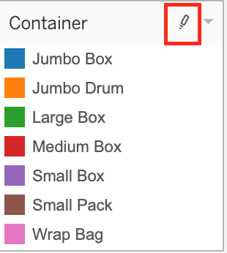

* 

**Format the Legends**

* 

**Toggle the highlighting on/off.**

**(Correct)**

* 

**Edit the Colors**

* 

**Highlight the largest value**

**Explanation**

**IMPORTANT QUESTION** - Lot of students have seen it recently in the exam, so please pay attention.

The correct answer is **Toggle the highlighting ON/OFF**. If selected, whichever value you choose from this legend will be highlighted in the view. However, if it is deselected, then even if you choose a value in the Legend, it will NOT be highlighted.

**See below:**

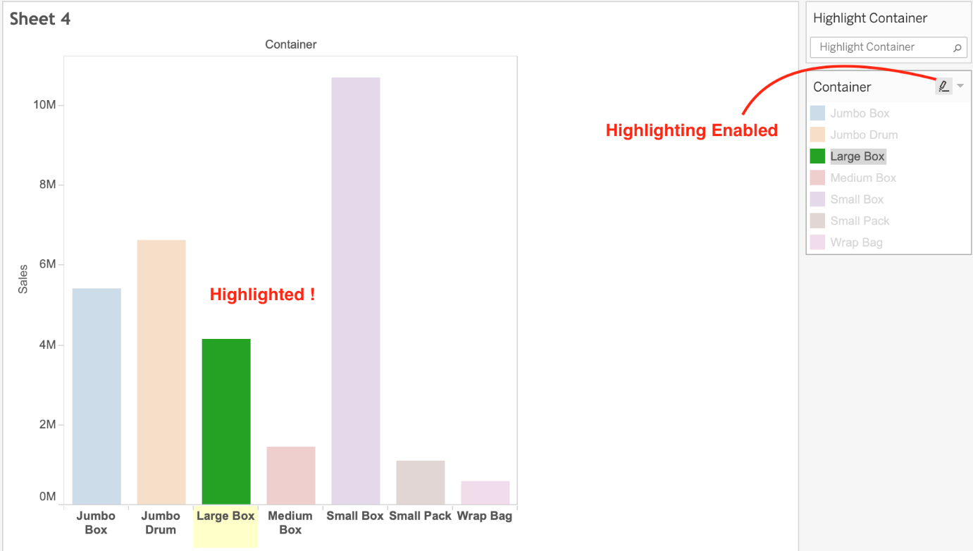

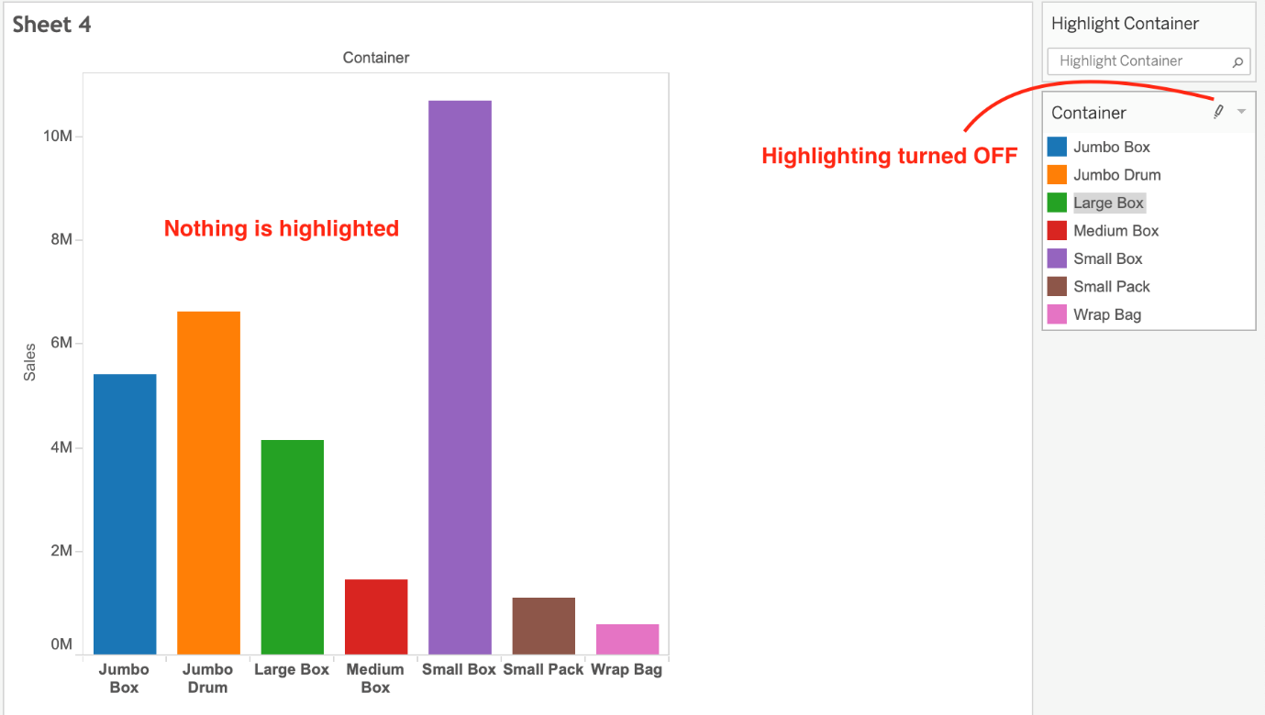

Bottom of Form

Top of Form

Question 14: **Correct**

**Which of the following options best describe measures?**

* 

**They are numerical, qualitative**

* 

**They are categorical, qualitative**

* 

**They are numerical, quantitative**

**(Correct)**

* 

**They are categorical, quantitative**

**Explanation**

Data fields are made from the columns in your data source. Each field is automatically assigned a data type (such as integer, string, date), and a role: Discrete Dimension or Continuous Measure (more common), or Continuous Dimension or Discrete Measure (less common).

***Dimensions*** contain qualitative values (such as names, dates, or geographical data). You can use dimensions to categorize, segment, and reveal the details in your data. Dimensions affect the level of detail in the view.

***Measures* contain numeric, quantitative values** that you can measure. Measures can be aggregated. When you drag a measure into the view, Tableau applies an aggregation to that measure (by default).

**Reference:** <https://help.tableau.com/current/pro/desktop/en-us/datafields_typesandroles.htm>

Bottom of Form

Top of Form

Question 15: **Incorrect**

**If you have a dashboard and are displaying its filter, how can you rearrange it?**

* 

**By clicking anywhere inside the filter and dragging it.**

* 

**By clicking on the dropdown and dragging the filter**

* 

**By clicking on the 2 lines on top and dragging the filter.**

**(Correct)**

* 

**By clicking on the filter title and dragging it.**

**(Incorrect)**

**Explanation**

You can drag the filter by clicking on the 2 lines on top, and then dragging the filter as shown:

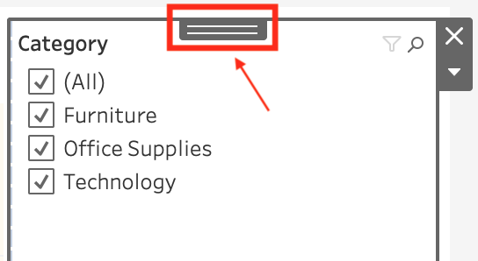

Bottom of Form

Top of Form

Question 16: **Incorrect**

**Suppose I have the following view. What will be the total number of marks if I drag a new measure to the row shelf vs the column shelf?**

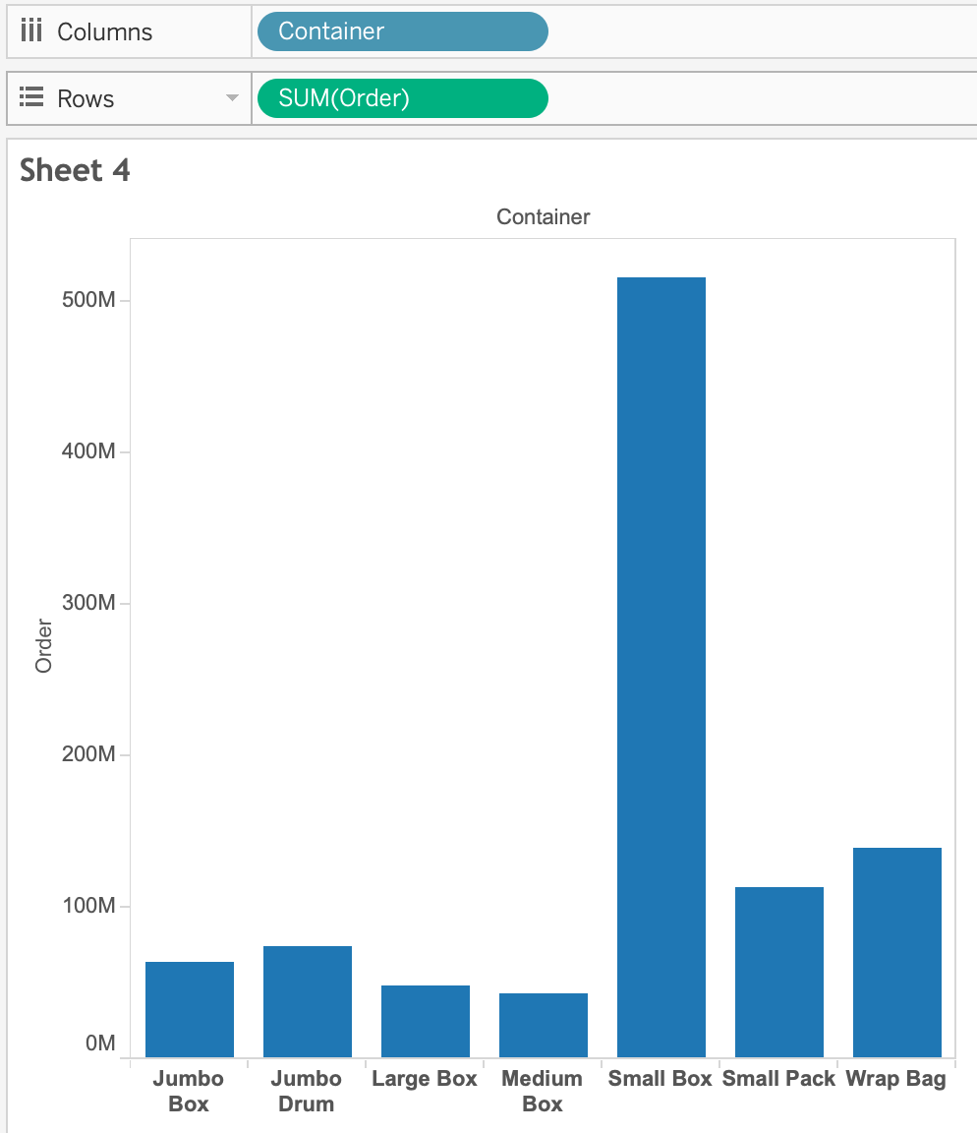

* 

**If dragged to row shelf : 7 marks ; If dragged to column shelf : 14 marks**

* 

**If dragged to row shelf : 14 marks ; If dragged to column shelf : 7 marks**

**(Correct)**

* 

**If dragged to row shelf : 7 marks ; If dragged to column shelf : 7 marks**

**(Incorrect)**

* 

**If dragged to row shelf : 14 marks ; If dragged to column shelf : 14 marks**

**Explanation**

This is a tricky question often asked in the exam.

If we drag a new measure to the row shelf, the following happens:

We now have 2 rows, and the same 7 columns for both these rows. **Therefore, 2x7 = 14 marks!**

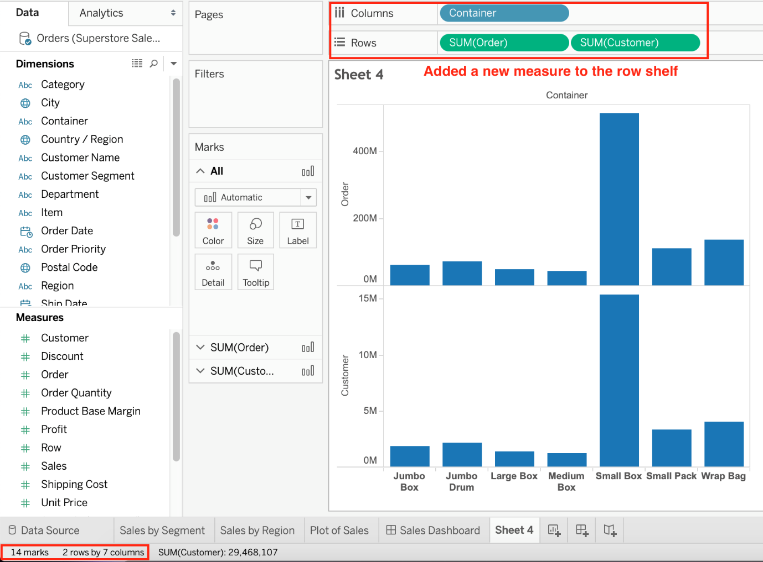

But if we drag the same measure to the column shelf, we have just 1 row and a chart created for each of the columns. **So (1x7) = 7 marks!**

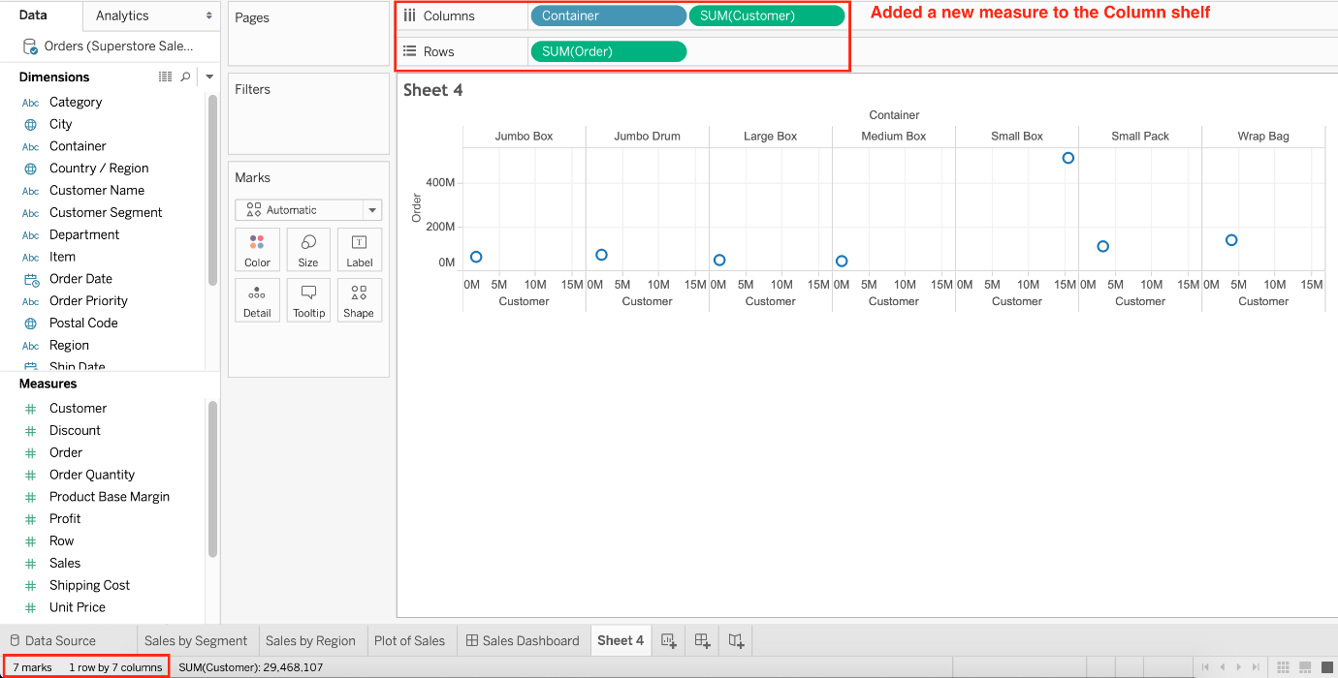

**Reference and notes:** <https://medium.com/@justindixon91/tableau-specialist-exam-notes-part-4-understanding-tableau-concepts-f78de83fdd35>

Bottom of Form

Top of Form

Question 17: **Correct**

**A union of two tables usually results in  an _____________________**

* 

**increase in the number of rows**

**(Correct)**

* 

**increase in the number of columns**

* 

**decrease in the number of rows**

* 

**decrease in the number of columns**

**Explanation**

**From the official Tableau documentation:**

You can union your data to combine two or more tables by **appending values (ROWS)** from one table to another. To union your data in Tableau data source, the tables must come from the **same** connection.

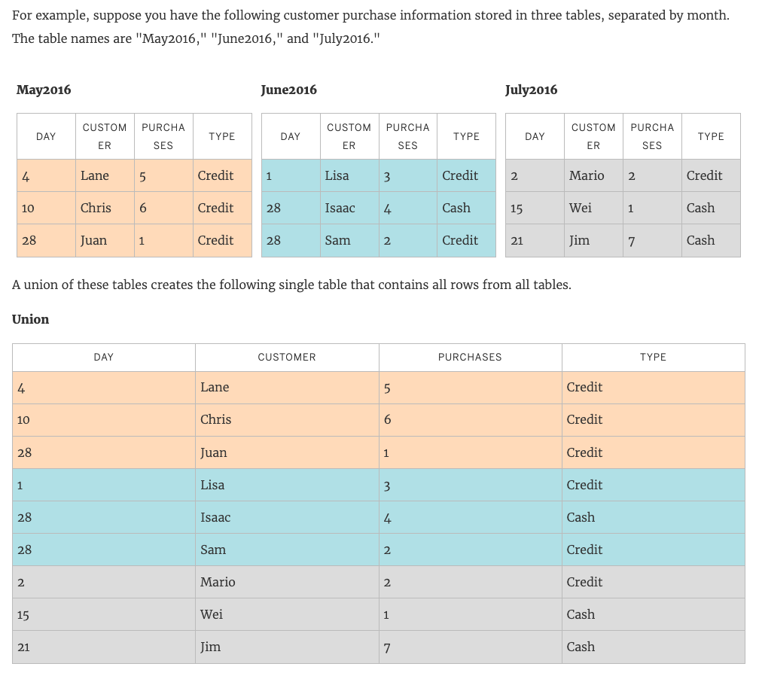

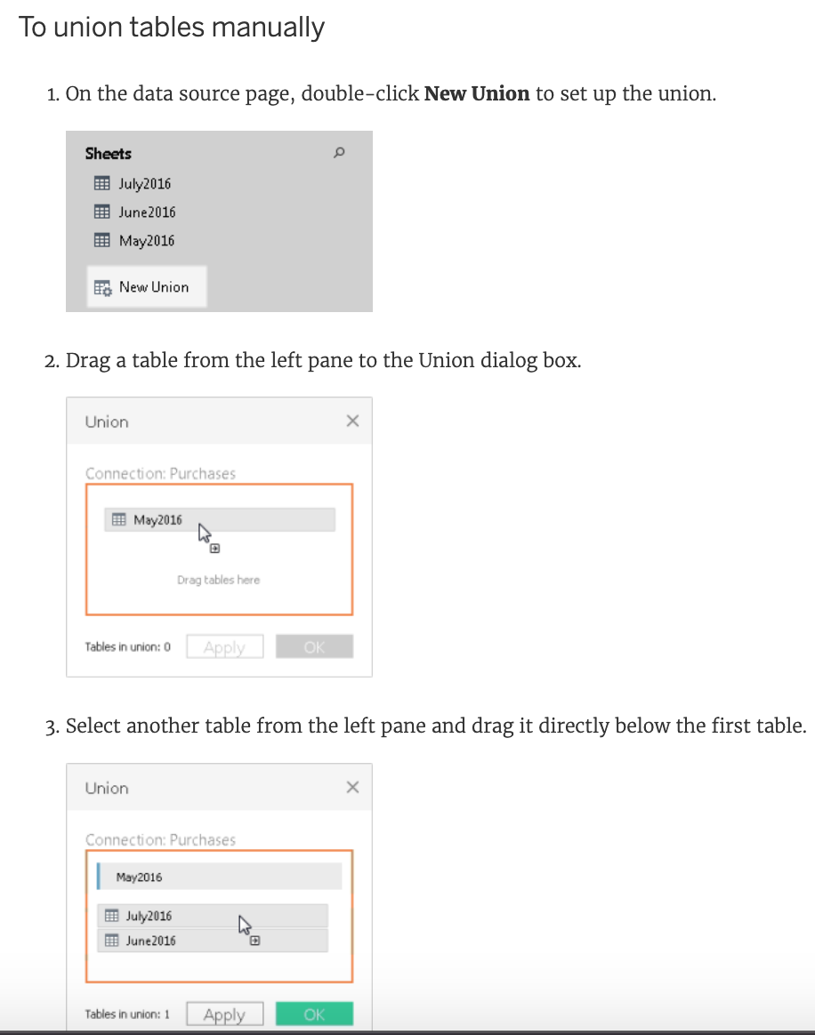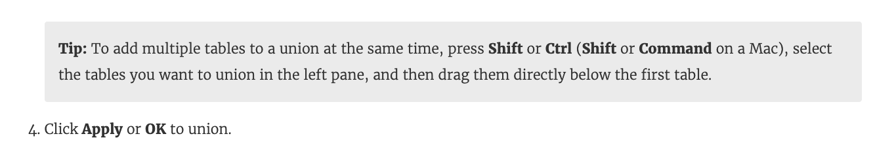

**Reference:**<https://help.tableau.com/current/pro/desktop/en-us/union.htm>

Bottom of Form

Top of Form

Question 18: **Correct**

**Beginning in version 10.5, when you create a new extract, it uses the _________ format instead of the .tde format.**

* 

**.tdex**

* 

**.twbx**

* 

**.hyper**

**(Correct)**

* 

**.tds**

**Explanation**

Beginning in version 10.5, when you create a new extract, it uses the **.hyper** format instead of the .tde format.

Extracts in the .hyper format take advantage of the improved data engine, which supports the same fast analytical and query performance as the data engine before it, but for **even larger extracts.**

Although there are many benefits of using .hyper extracts, the primary benefits include the following:

**1) Create larger extracts:** You can create extracts with billions of rows of data. Because .hyper extracts can support more data, you can consolidate .tde extracts that you previously had to create separately into a single .hyper extract.

**2) Create and refresh extracts faster:** While Tableau has always optimized performance for creating and refreshing extracts, version 2020.3 supports faster extract creation and refreshes for even larger data sets.

**3) Experience better performance when interacting with views that use extract data sources:** Although smaller extracts continue to perform efficiently, larger extracts perform more efficiently.

**Reference:** <https://help.tableau.com/current/pro/desktop/en-us/extracting_upgrade.htm>

Bottom of Form

Top of Form

Question 19: **Correct**

**For which of the following charts, does the Size option on the Marks card not work?**

* 

**Bar Chart**

* 

**Pie Chart**

* 

**Tree Map**

**(Correct)**

* 

**Gantt Chart**

**Explanation**

You can adjust the size for all charts except the Tree Map. You use dimensions to define the structure of the treemap, and measures to define the size or color of the individual rectangles. Treemaps are a relatively simple data visualization that can provide insight in a visually attractive format.

In a Tree Map, the measure itself defines the size and colour! The greater the sum of Measure for each category, the darker and larger its box.



**Reference:** <https://help.tableau.com/current/pro/desktop/en-us/buildexamples_treemap.htm>

Bottom of Form

Top of Form

Question 20: **Correct**

**Is it possible to make a Measure discrete?**

* 

**Yes**

**(Correct)**

* 

**No**

**Explanation**

Of course! Follow along:

**Right click on any measure, and choose Discrete as shown:**

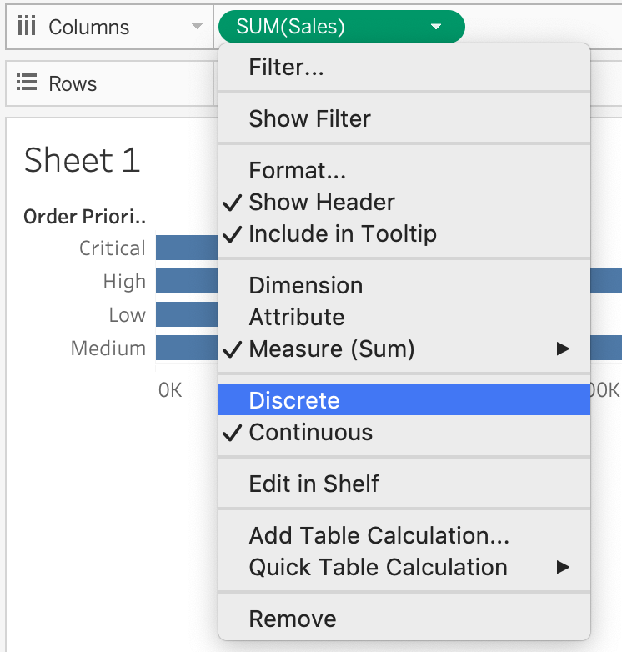

Once you do this, the green pill becomes **blue** in colour, indicating that it is now **Discrete**!

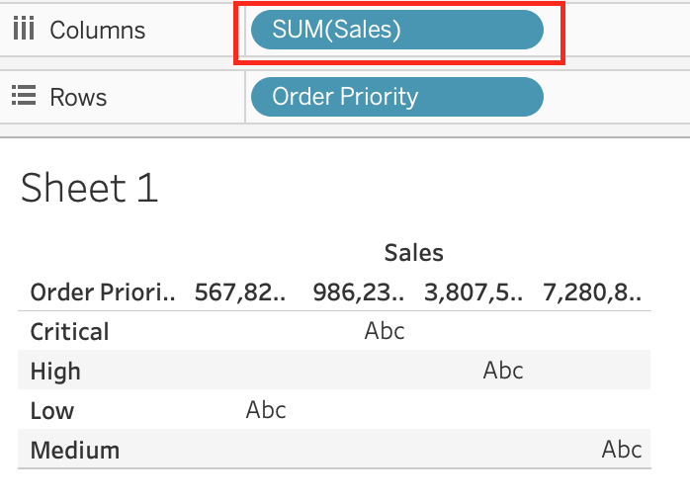

**Reference:**<https://help.tableau.com/current/pro/desktop/en-us/datafields_typesandroles.htm>

Bottom of Form

Top of Form

Question 21: **Correct**

**How can you add color to marks in the view in Tableau?**

* 

**From the Analytics pane, drag a model to Color on the Marks card.**

* 

**Click on Data in the main menu above, and click on choose color.**

* 

**From the Data pane, drag a field to Color on the Marks card.**

**(Correct)**

* 

**In the column/row shelf, right click the field and click on edit in shelf to select the color.**

**Explanation**

**To assign a color to marks in the view, do the following:**

From the **Data** pane, drag a field to Color on the Marks card.

Tableau applies different colors to marks based on the field’s **values and members**. For example, if you drop a discrete field (a blue field), such as Category, on Color, the marks in the view are broken out by category, and each category is assigned a color.



If you drop a continuous field, such as SUM(sales), on Color, each mark in the view is colored based on its sales value.



Bottom of Form

Top of Form

Question 22: **Correct**

**What do the colours Blue and Green represent in Tableau?**

* 

**Dimensions and Measures**

* 

**Continuous and Discrete**

* 

**Measures and Dimensions**

* 

**Discrete and Continuous**

**(Correct)**

**Explanation**

Important question! If you selected Dimension and Measure, don't worry! It is a very common mistake. But we're here to learn aren't we?

When you connect to a new data source, Tableau assigns each field in the data source as dimension or measure in the Data pane, depending on the type of data the field contains. You use these fields to build views of your data.

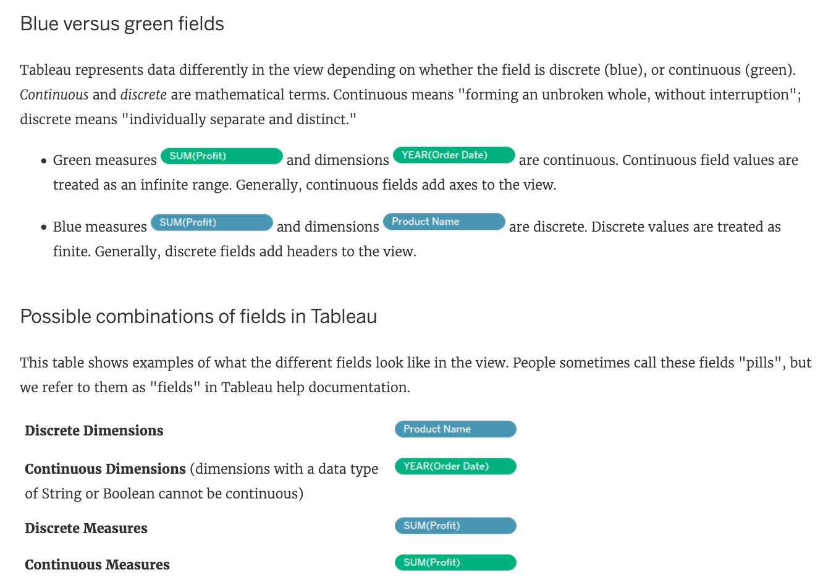

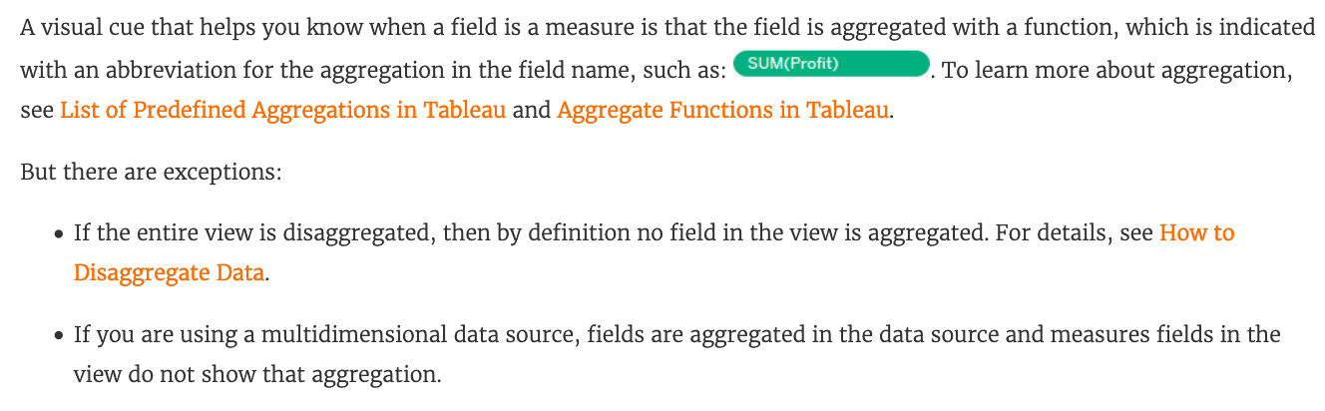

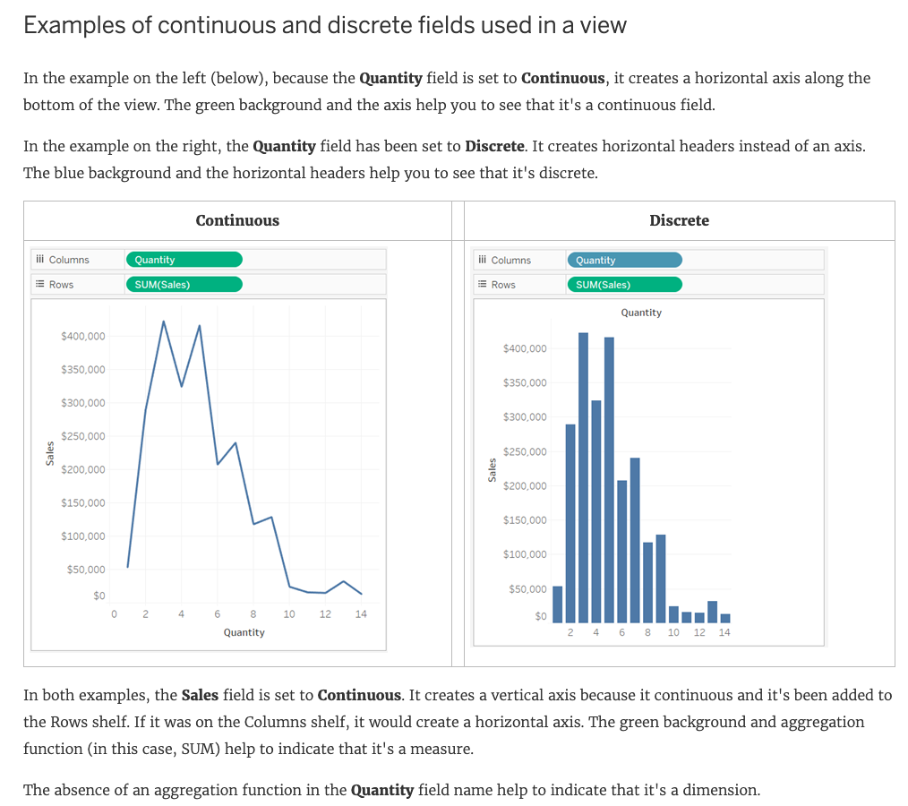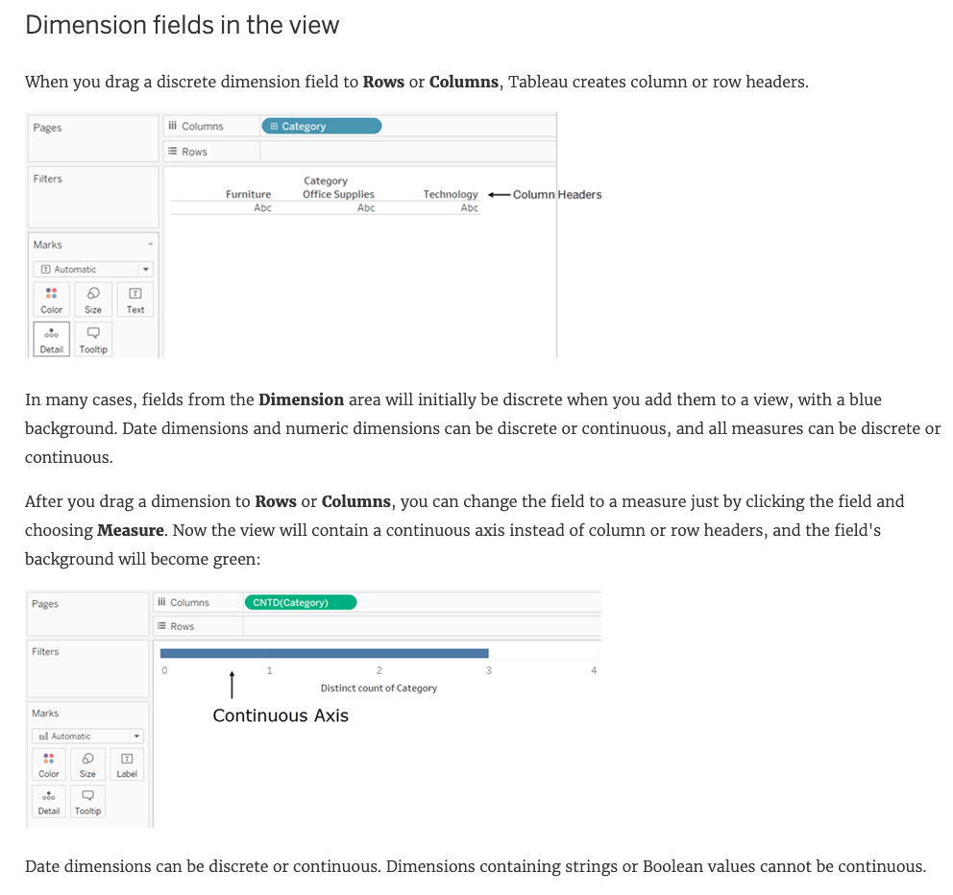

**Reference:**<https://help.tableau.com/current/pro/desktop/en-us/datafields_typesandroles.htm>

Bottom of Form

Top of Form

Question 23: **Correct**

**Which of the following are true about dimensions?**

* 

**Dates are mostly placed in dimensions by default for relational data sources**

**(Correct)**

* 

**They affect the level of detail in the view**

**(Correct)**

* 

**They contain qualitative values (such as names, dates, or geographical data)**

**(Correct)**

* 

**They contain contain numeric, quantitative values**

**Explanation**

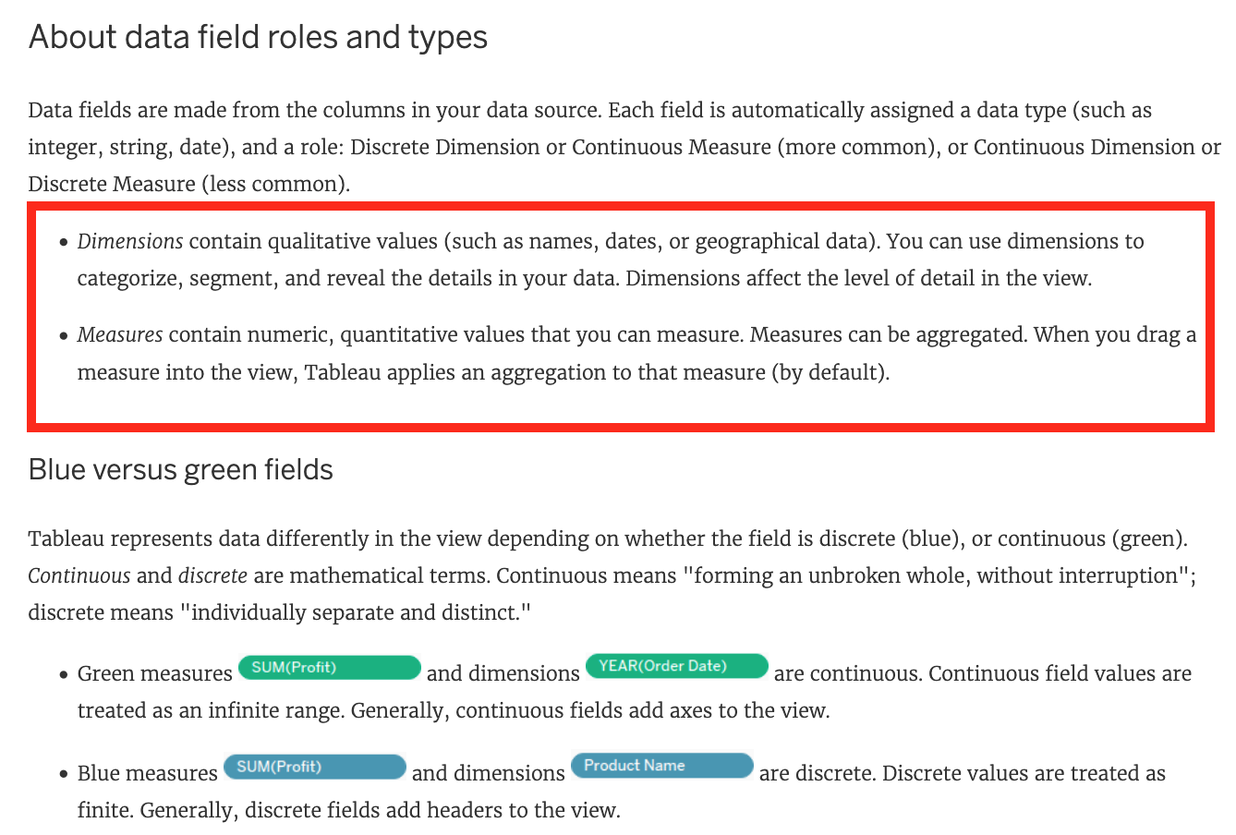

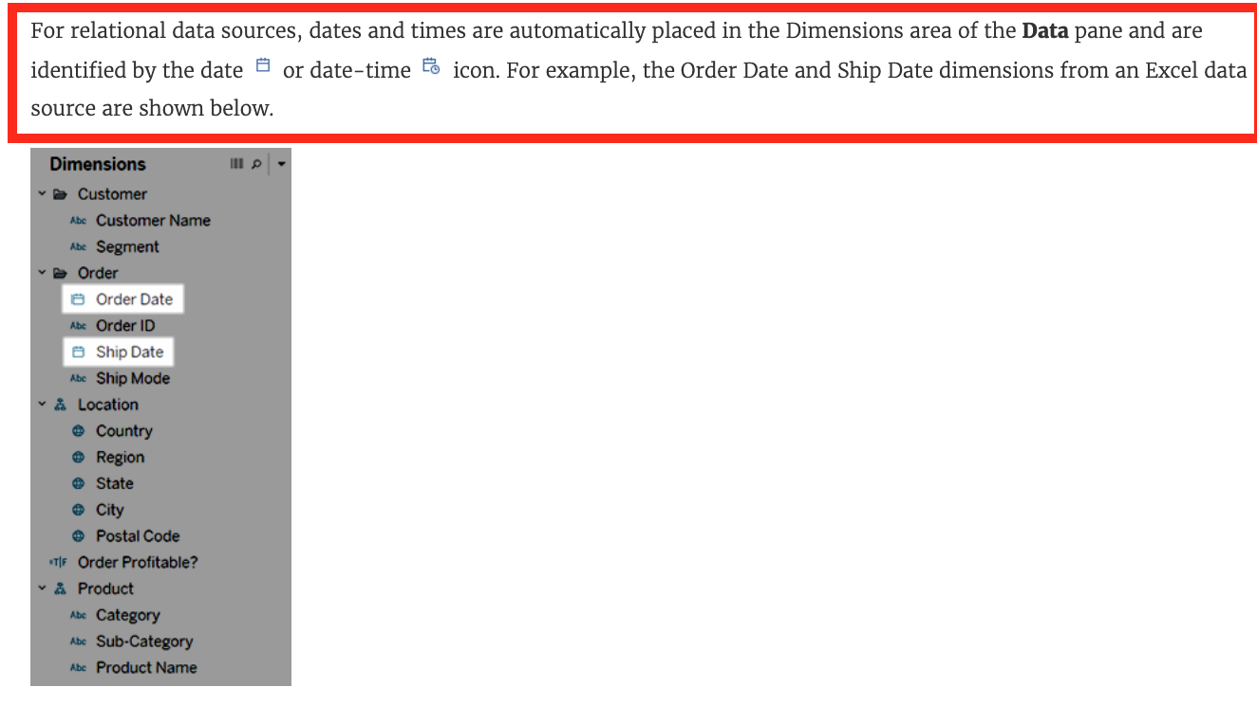

Measures contain numeric quantitative values hence that option is incorrect.

**Reference 1:** <https://help.tableau.com/current/pro/desktop/en-us/datafields_typesandroles.htm>

**Reference 2:**<https://help.tableau.com/current/pro/desktop/en-us/dates.htm>

Bottom of Form

Top of Form

Question 24: **Correct**

**When field names in the Union do not match, then:**

* 

**An error is raised and both fields are dropped from the resulting Union**

* 

**Only one field name is present in the Union with null values**

* 

**Only one field name is present in the Union with correct values since Tableau automatically corrects field name mismatch**

* 

**Both field names are present in the Union, but contain several null values**

**(Correct)**

**Explanation**

**By default, both field names are present in the Union, but contain several null values!**

When field names in the union do not match, fields in the union contain null values. **You can merge the non-matching fields into a single field using the merge option to remove the null values.** When you use the merge option, the original fields are replaced by a new field that displays the **first** non-null value for each row in the non-matching fields.

You can also create your own calculation or, if possible, modify the underlying data to combine the non-matching fields.

For example, suppose you have the following customer purchase information stored in three tables, separated by month. The table names are "May2016," "June2016," and "July2016."

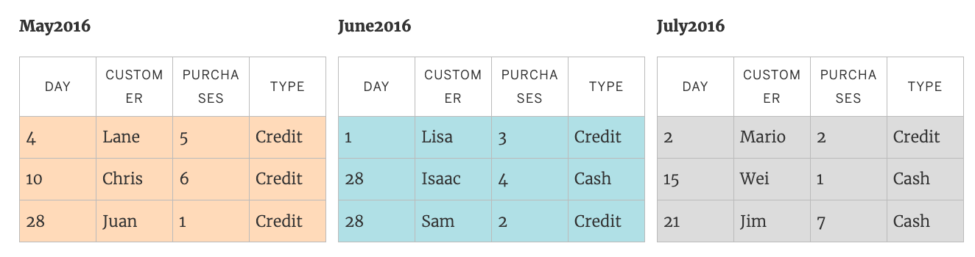

A union of these tables creates the following single table that contains all rows from all tables.

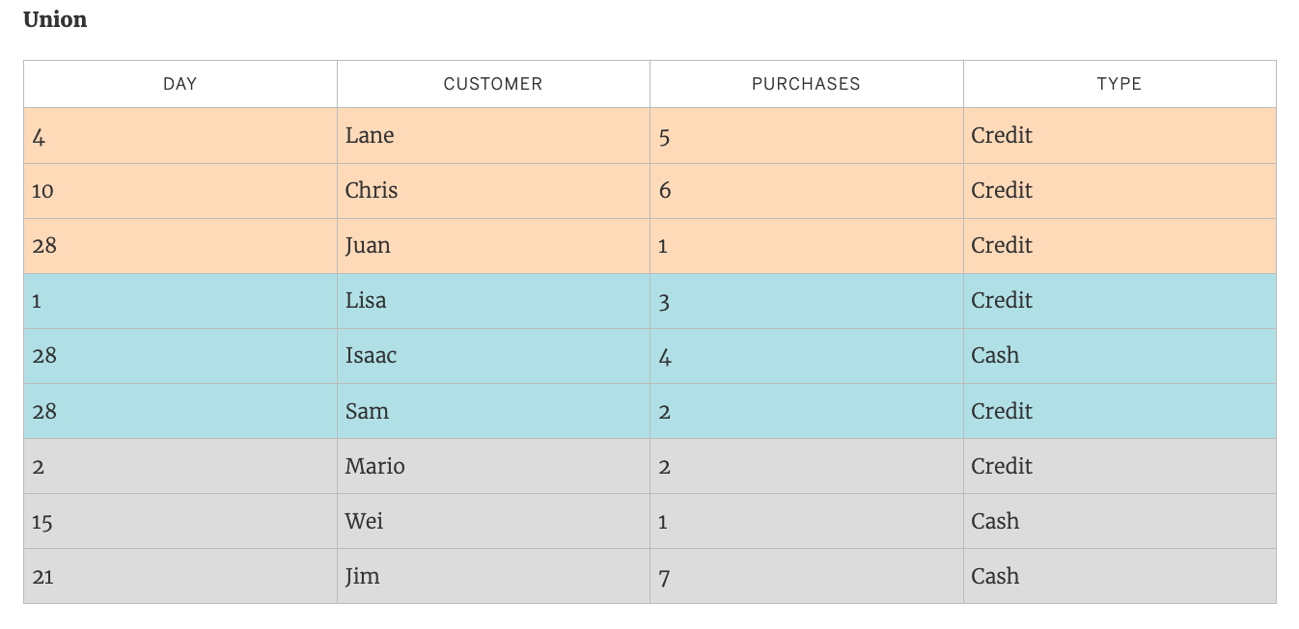

Now suppose a fourth table, "August2016", is added to the underlying data. Instead of the standard "Customer" field name, it contains an abbreviated version called "Cust."

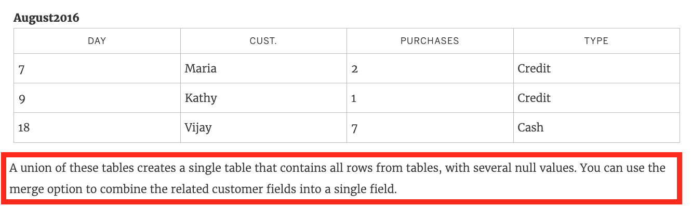

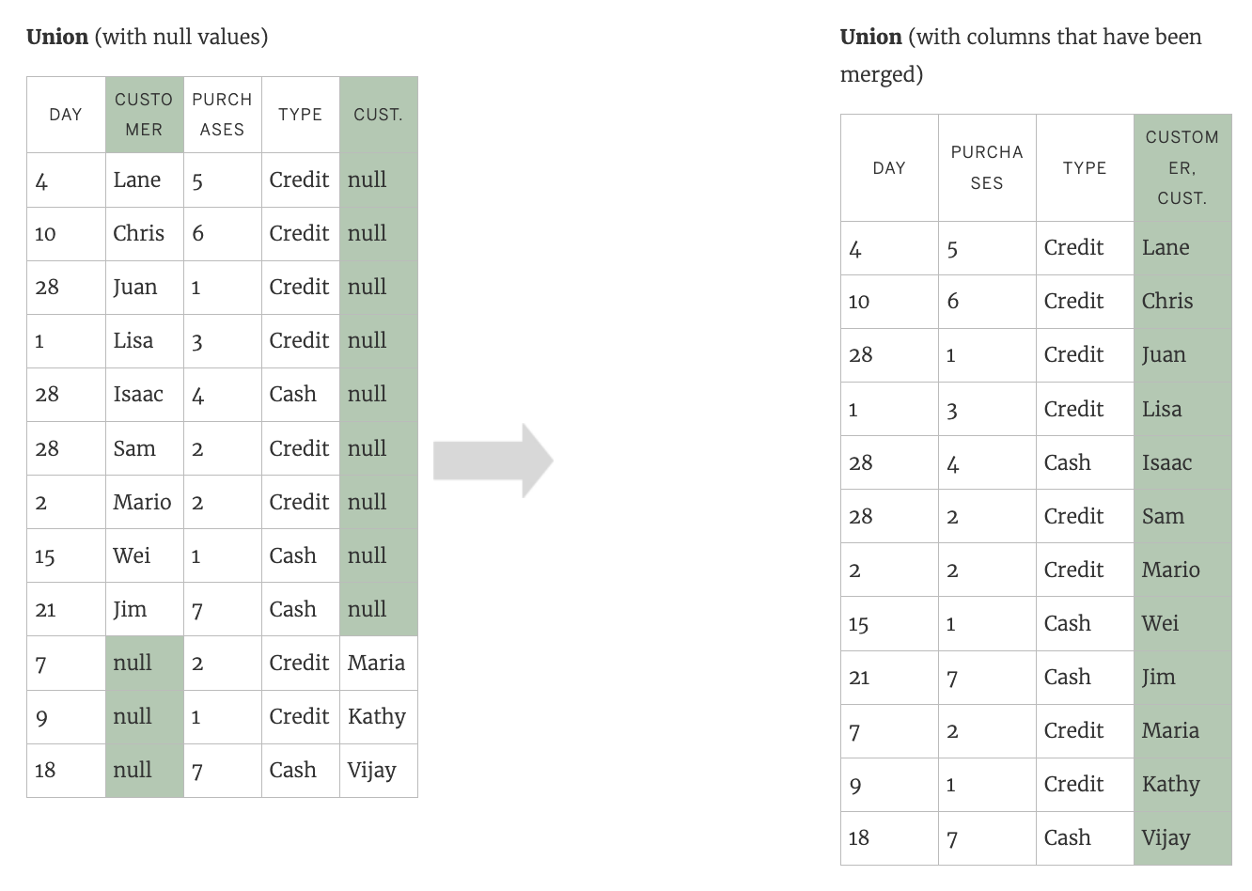

**Reference:**<https://help.tableau.com/current/pro/desktop/en-us/union.htm>

Bottom of Form

Top of Form

Question 25: **Correct**

**Which of the following is a compelling reason to export a sheet in Tableau to a PDF?**

* 

**If we want to interact with the visualisation.**

* 

**If we want to use filters in the visualisation.**

* 

**If we want to dynamically enter parameters to the visualisation.**

* 

**If we want a static view of the visualisation.**

**(Correct)**

**Explanation**

**Exporting the visualisation gives us a static view of the visualisation.**

It is **NOT** possible to interact with it, use filters, or dynamically enter anything in a visualisation exported PDF.

In Tableau Desktop, you can save views as PDF files rather than printing them as hard copies. You do not need to have Adobe Acrobat installed on your computer.

When you print an individual sheet to PDF, filters in the view are **not** included. **To show filters, create a dashboard containing the sheet and export the dashboard to PDF. (IMPORTANT)**

**Reference:**<https://help.tableau.com/current/pro/desktop/en-us/printing.htm>

Bottom of Form

Top of Form

Question 26: **Incorrect**

**How can you format an axis as Bold in Tableau?**

* 

**By right clicking on the axis, choosing Edit Axis, and then setting its font to bold.**

**(Incorrect)**

* 

**By right clicking on the axis, choosing format, and then setting its font to bold.**

**(Correct)**

* 

**By clicking on Format on the main menu bar, choosing field labels, and setting it to bold.**

* 

**By choosing the axis and selecting Command/Control + B on your keyboard**

**Explanation**

**To make an axis bold, simply right click it, select format, and then click on Font to choose Bold:**

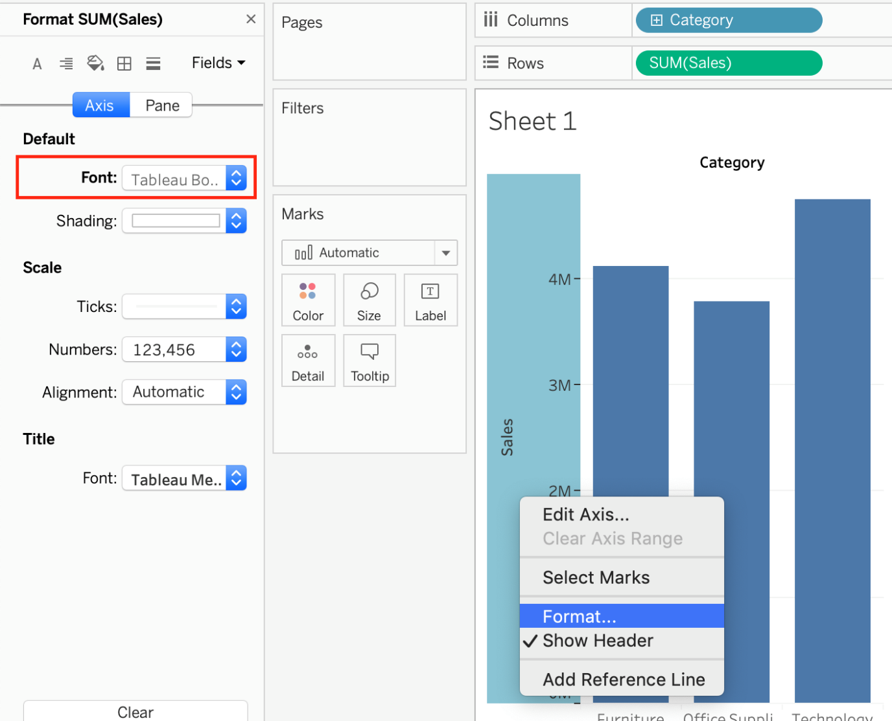

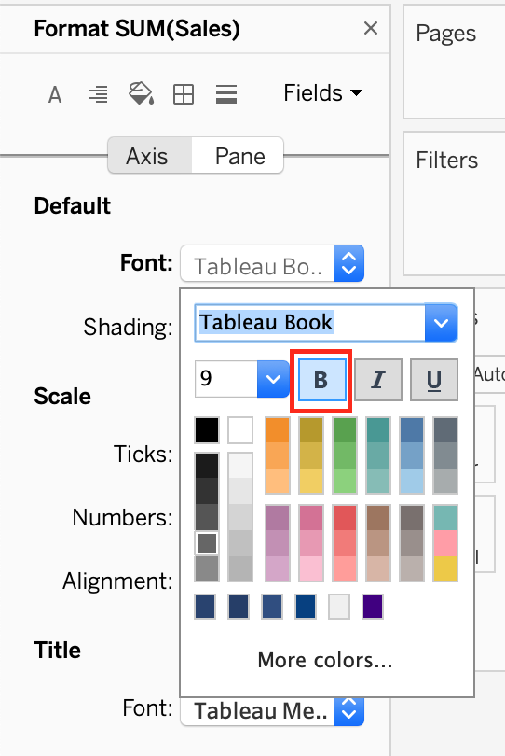

None of the other options are valid ways to make the axis bold.

**Read more about editing axis:**<https://help.tableau.com/current/pro/desktop/en-us/formatting_editaxes.htm>

Bottom of Form

Top of Form

Question 27: **Correct**

**In which of the following scenarios would having a live connection be more beneficial than using an extract?**

* 

**Analyzing historical housing prices**

* 

**Analyzing and tracking real time flight updates**

**(Correct)**

* 

**Analyzing real time data from production systems**

**(Correct)**

* 

**Analyzing real time stock prices**

**(Correct)**

* 

**Analyzing a subset of a dataset having 1 billion rows**

**Explanation**

**Extracts** would be more beneficial for analyzing historical prices where we won't be making use of any real time data being streamed. Same is the case for enormous datasets having billions of rows (extracts will be more efficient in analyzing subsets of such large data).

As for **live** stock prices, flight updates, real time updates from production or mission critical systems - having a live connection is the most logical choice, since we need access to the most fresh and recent data possible at all times!

Bottom of Form

Top of Form

Question 28: **Incorrect**

**Which of the following are valid ways to Bold the Tooltip content in Tableau?**

* 

**Click on Worksheet in the Menu bar, followed by Tooltip and select the bold option**

**(Correct)**

* 

**Click on Analysis, Tooltip options, and select bold.**

* 

**Click on Tooltip in the Marks card, and select bold.**

**(Correct)**

* 

**Right click, click format and then under the default worksheet formatting, choose Tooltip and make it bold.**

**(Correct)**

**Explanation**

Lot of students have been seeing this question in the exam lately, and wanted me to include this question so here it is. Follow along -

**1) Click on Worksheet in the Menu bar, followed by Tooltip and select the bold option**

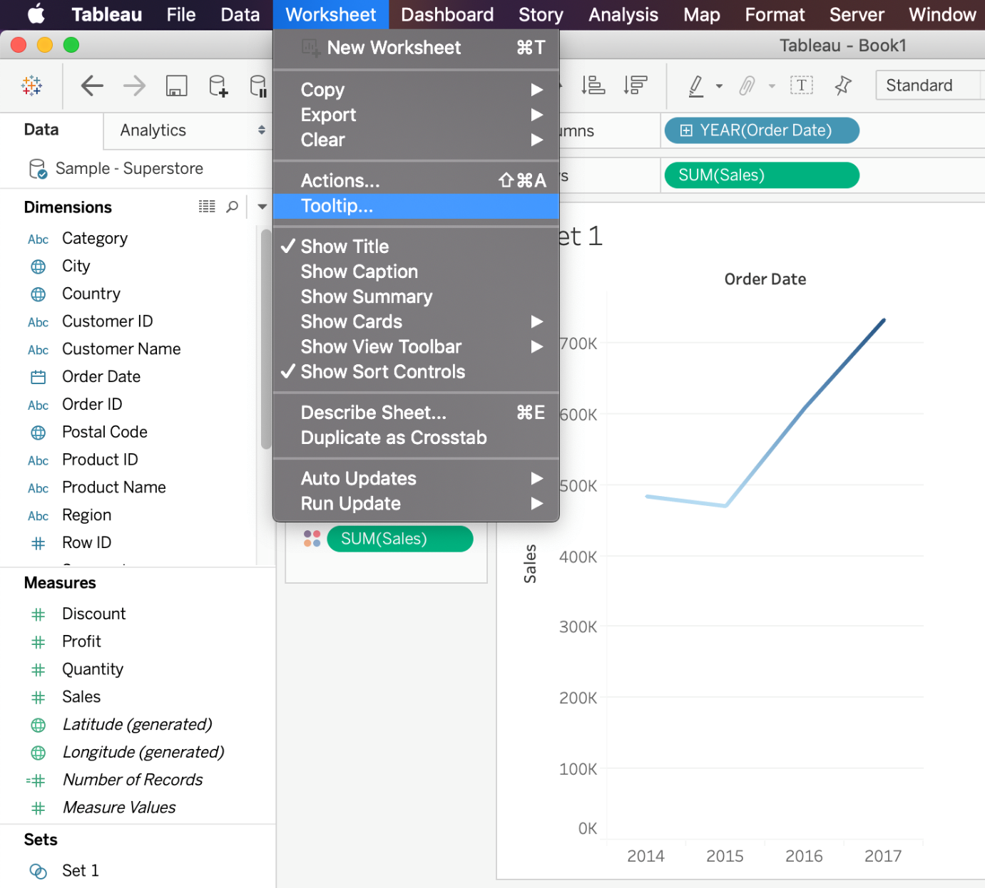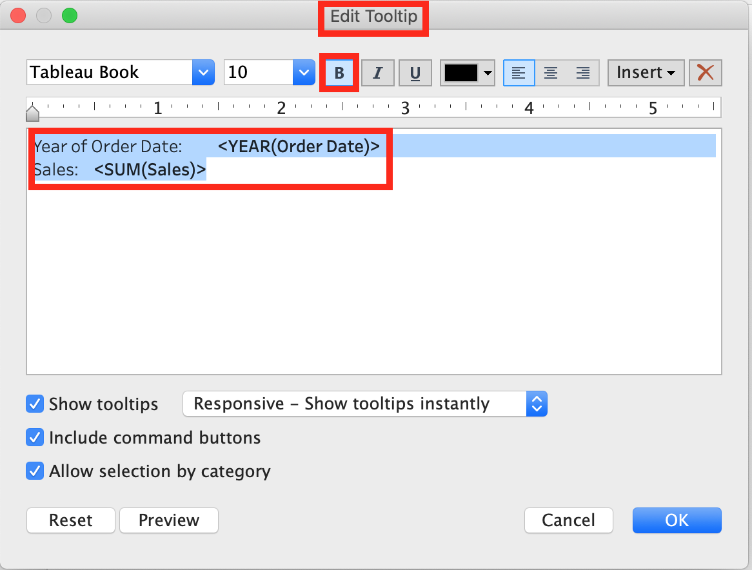

**2) Click on Tooltip in the Marks card, and select bold.**

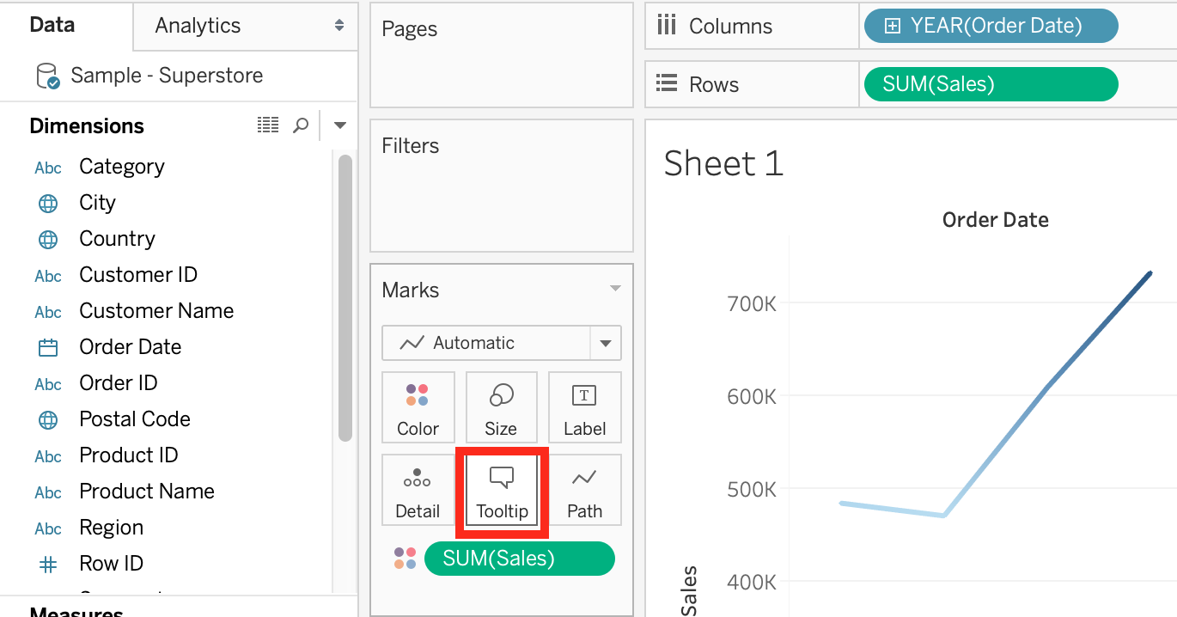



**3) Right click, click format and then under the default worksheet formatting, choose Tooltip and make it bold.**

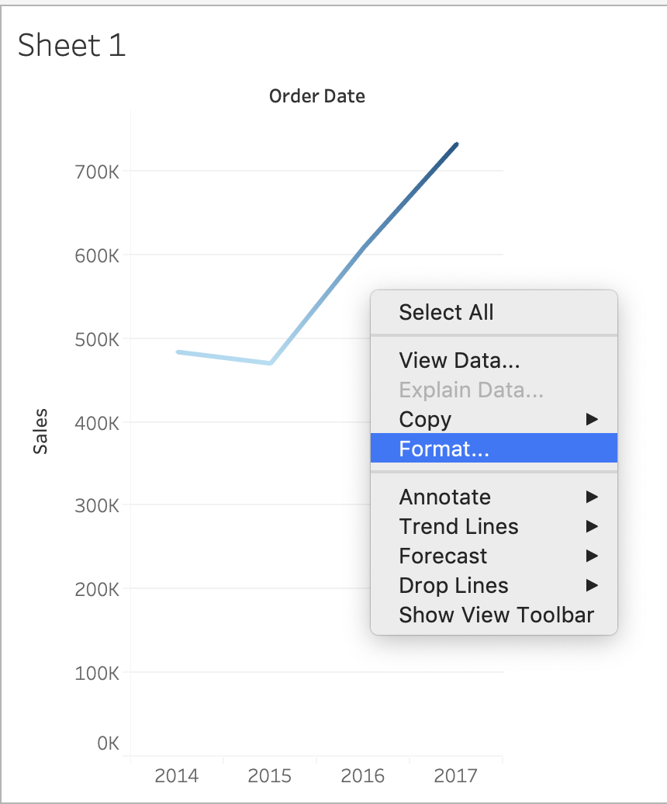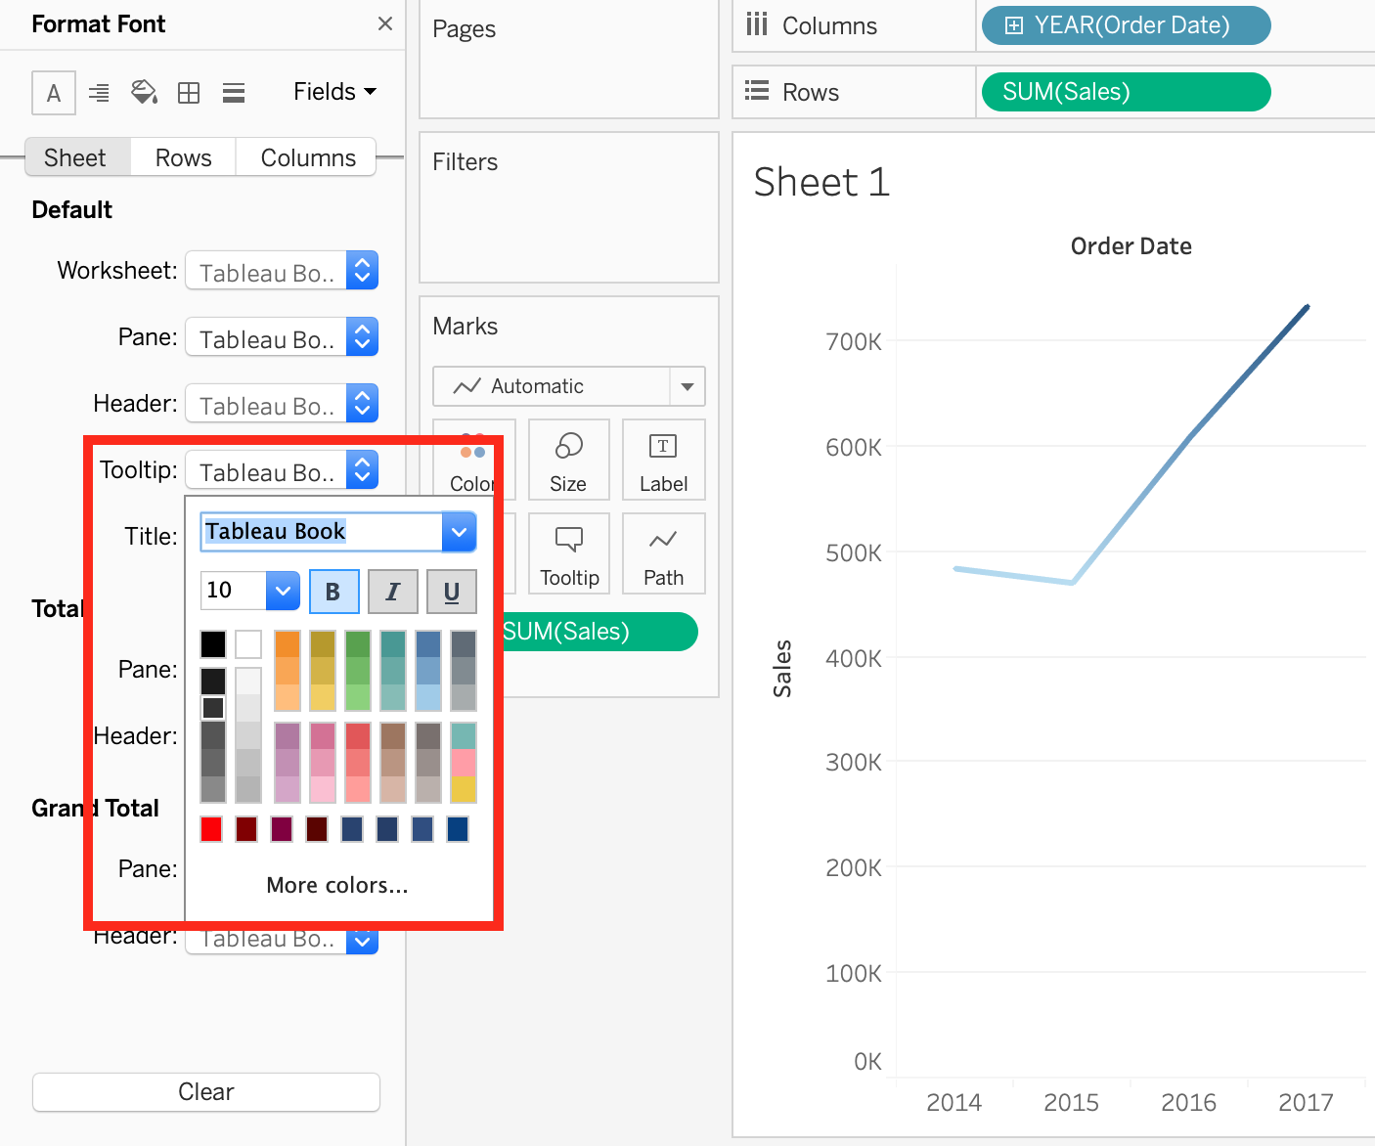

There exists no option to Bold the tooltip contents by clicking Analysis. Hence, it is an incorrect choice.

Bottom of Form

Top of Form

Question 29: **Correct**

**Which of the following is a benefit of using a Tableau Data Source (.tds)?**

* 

**To create a local copy of a subset or entire data set that you can use to share data with others, when you need to work offline, and improve performance.**

* 

**To create a single zip file that contains a workbook along with any supporting local file data and background images. This is great for sharing your work with others who don’t have access to the original data.**

* 

**To hold one or more worksheets, plus zero or more dashboards and stories.**

* 

**To not contain the actual data but rather the information necessary to connect to the actual data as well as any modifications you've made on top of the actual data such as changing default properties, creating calculated fields etc**

**(Correct)**

**Explanation**

The following are the official definitions from the Tableau documentation for the various file types:

**1) .tds (Tableau Data Source) -**To not contain the actual data but rather the information necessary to connect to the actual data as well as any modifications you've made on top of the actual data such as changing default properties, creating calculated fields etc. **(CORRECT ANSWER)**

**2) .twbx ( Tableau packaged workbook) -**To create a single zip file that contains a workbook along with any supporting local file data and background images. This is great for sharing your work with others who don’t have access to the original data.

**3) Extract (.hyper or .tde) –**To create a local copy of a subset or entire data set that you can use to share data with others, when you need to work offline, and improve performance.

**3) (.twb) Workbooks –**To hold one or more worksheets, plus zero or more dashboards and stories.

**Reference:**<https://help.tableau.com/current/pro/desktop/en-us/environ_filesandfolders.htm>

Bottom of Form

Top of Form

Question 30: **Incorrect**

**Which of the following can you add a reference line to?**

* 

**Calculated Fields**

**(Correct)**

* 

**Measures**

**(Correct)**

* 

**Dimensions**

**(Incorrect)**

* 

**Groups**

**Explanation**

You can add reference lines, bands, distributions, or (in Tableau Desktop but not on the web) box plots to any **continuous** **axis** in the view.

**Reference Lines** - You can add a reference line at a **constant or computed** value on the axis. Computed values can be based on a specified field. You can also include confidence intervals with a reference line.

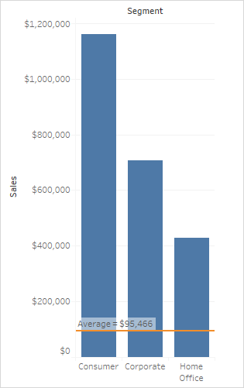

**Reference:** <https://help.tableau.com/current/pro/desktop/en-us/reference_lines.htm>

Bottom of Form

Top of Form

Question 31: **Correct**

**Suppose you have a bar chart. When we group by labels in a view, which of the following happens?**

* 

**Trick question! It is not possible to group by labels.**

* 

**Nothing changes in the view, but a group is created in the Dimensions shelf.**

* 

**The colours of the members selected are now the same, and different for the rest of the members.**

* 

**A new mark (bar) is created, which consolidates all members of the group.**

**(Correct)**

**Explanation**

**\*Very important question\***

If we select the labels in the view and then group, a new **consolidated mark** is created - in our case bar since we are talking about a bar chart in the question. See below:

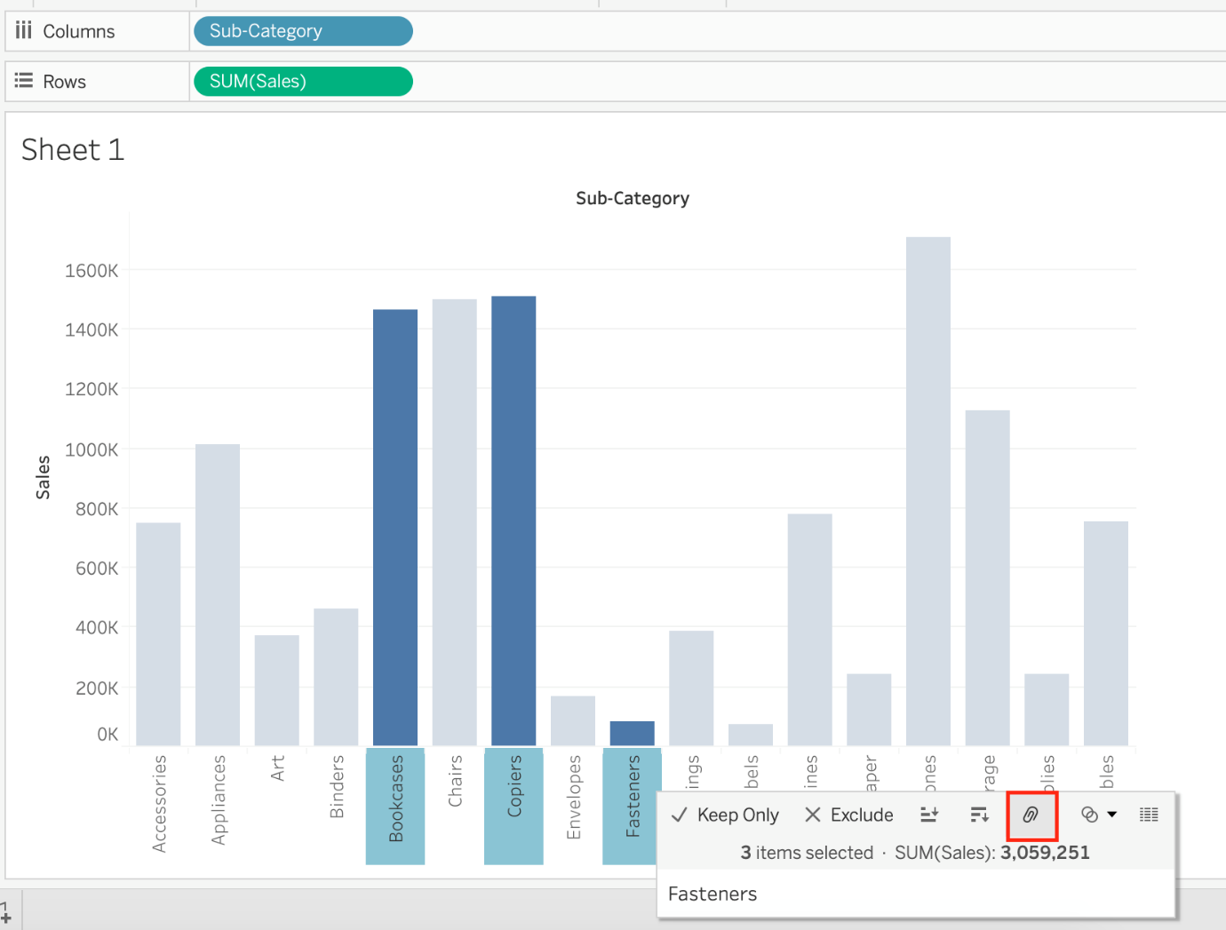

Then on grouping, a new bar is created, and the colour of all bars remain the same.

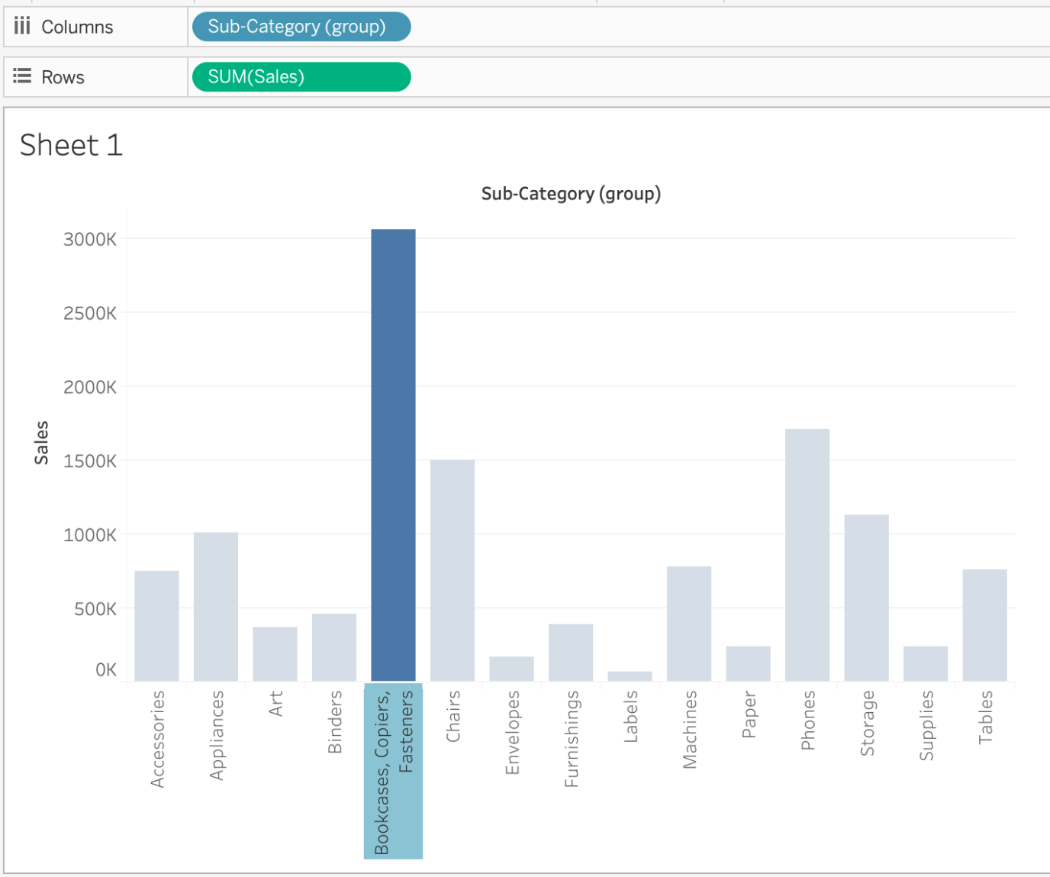

**Had we grouped by choosing the marks instead of the labels, the following would be the result:**

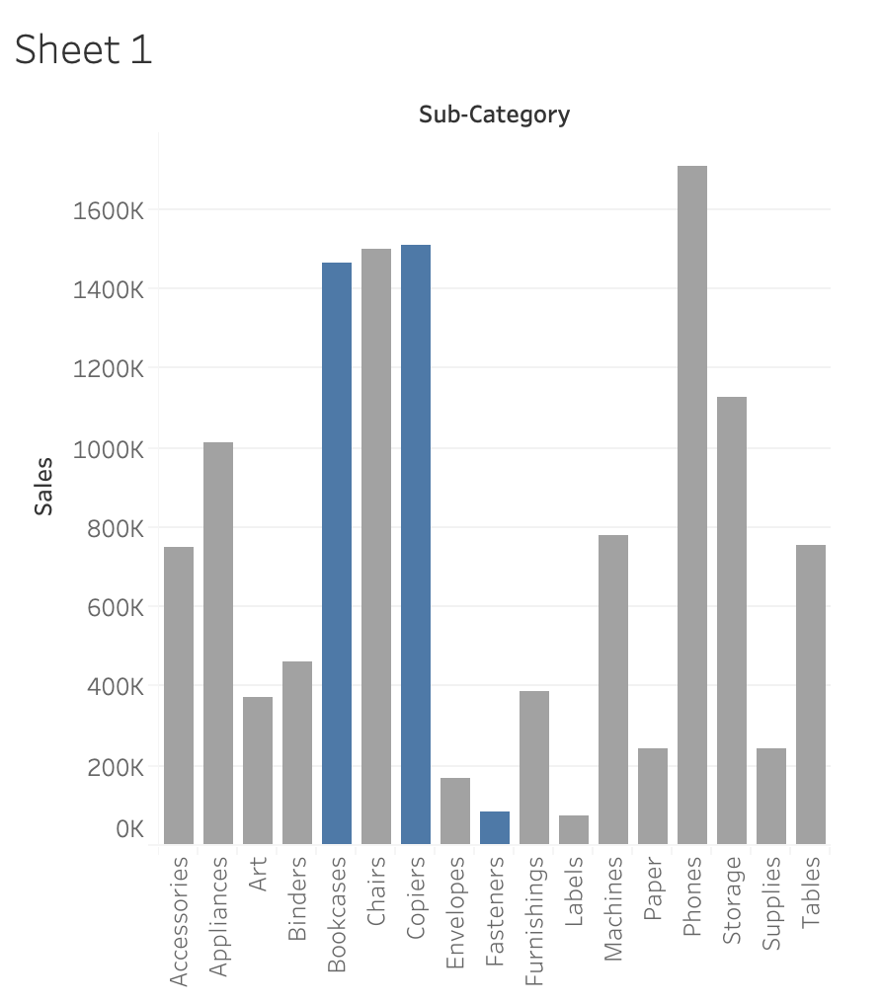

**Reference:** <https://help.tableau.com/current/pro/desktop/en-us/sortgroup_groups_creating.htm>

Bottom of Form

Top of Form

Question 32: **Correct**

**Which of the following calculations DO NOT need a quick table calculation?**

* 

**Rank**

* 

**Standard Deviation**

**(Correct)**

* 

**Moving Average**

* 

**Variance**

**(Correct)**

**Explanation**

For **Standard Deviation and Variance**, we don't need to use quick table calculations, since they are available by default. See below:

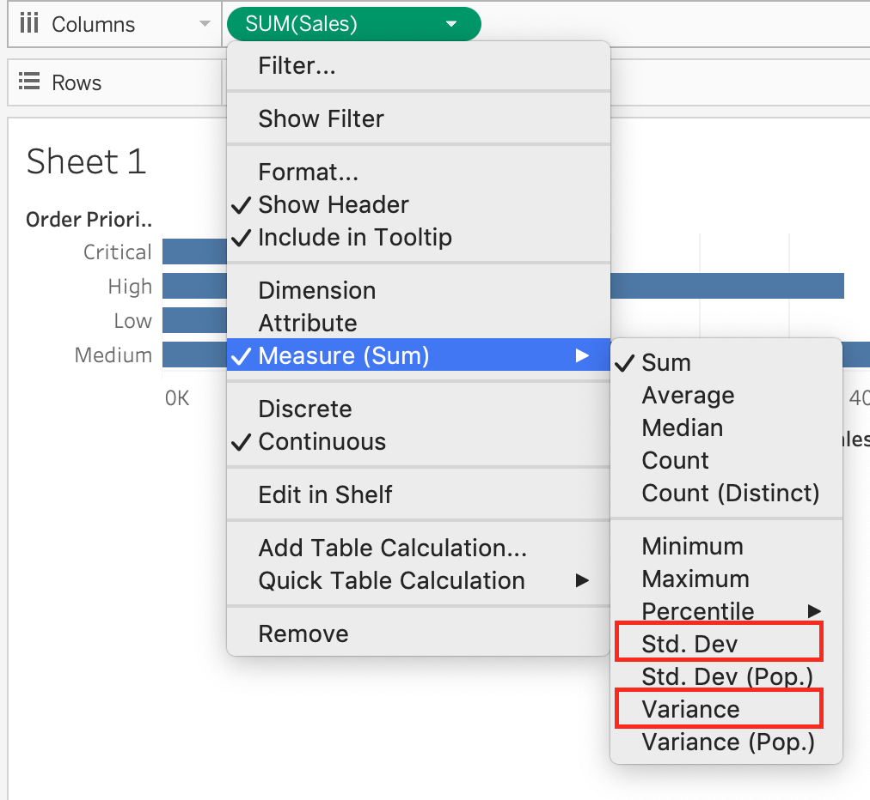

**However, as seen in the types of quick table calculations available in Tableau, Rank and Moving Average belong to only this category.**

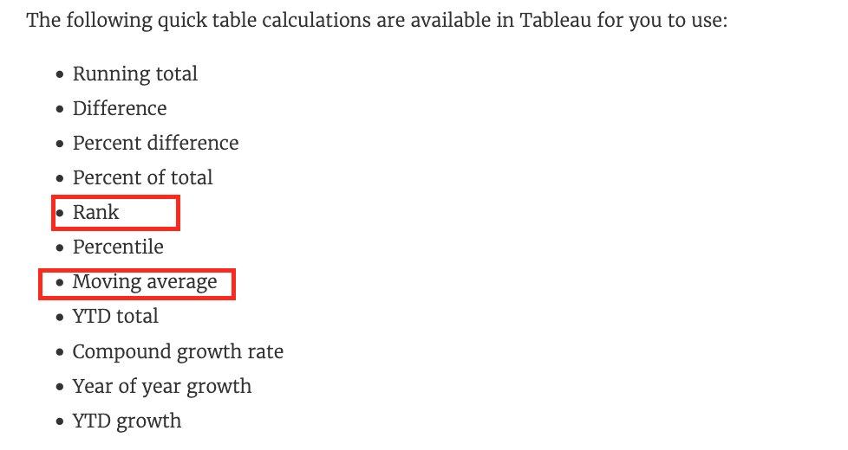

Bottom of Form

Top of Form

Question 33: **Correct**

**What is a story point in Tableau?**

* 

**A collection of worksheets**

* 

**A single worksheet or dashboard**

**(Correct)**

* 

**A collection of dashboards**

* 

**A collection of both worksheets and dashboards**

**Explanation**

In Tableau, a **story** is a sequence of visualizations that work together to convey information. You can create stories to tell a data narrative, provide context, demonstrate how decisions relate to outcomes, or to simply make a compelling case.

A story is a sheet, so the methods you use to create, name, and manage worksheets and dashboards also apply to stories (for more details, see [Workbooks and Sheets](https://help.tableau.com/current/pro/desktop/en-us/environ_workbooksandsheets.htm)). At the same time, a story is also a collection of sheets, arranged in a sequence. **Each individual sheet (worksheet or dashboard) in a story is called a story point.**

When you share a story —for example, by publishing a workbook to Tableau Public, Tableau Server, or Tableau Online—users can interact with the story to reveal new findings or ask new questions of the data.

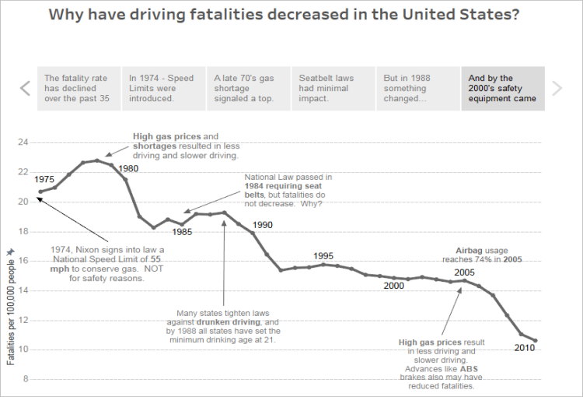

**Reference:** <https://help.tableau.com/current/pro/desktop/en-us/stories.htm>

Bottom of Form

Top of Form

Question 34: **Correct**

**Which of the following are benefits of combining sheets using dashboards?**

* 

**Easier to compare visualisations side by side**

**(Correct)**

* 

**Helps in faster analysis**

**(Correct)**

* 

**Provides the ability to use one sheet as a filter for other**

**(Correct)**

* 

**It is mandatory to combine sheets when using Tableau**

**Explanation**

**The only incorrect option is -** It is mandatory to combine sheets when using Tableau.

All others are valid advantages that Dashboards provide when using Tableau!

Bottom of Form

Top of Form

Question 35: **Correct**

**Which of the following can help us focus on specific data without removing data in the visualization?**

* 

**Filters**

* 

**Sets**

* 

**Clusters**

* 

**Highlighters**

**(Correct)**

**Explanation**

From the official documentation:

When you have a view with a large amount of data you might want to explore your data interactively and **highlight a specific mark or group of marks while still maintaining the context of where those marks show in your view.**

To do this you can turn on the Highlighter for one or more discrete fields that are included in your view and that affect the level of detail

**Example -** Here we just want to focus on Public Affairs college dimension, but don't want to filter out or remove the rest of the data:

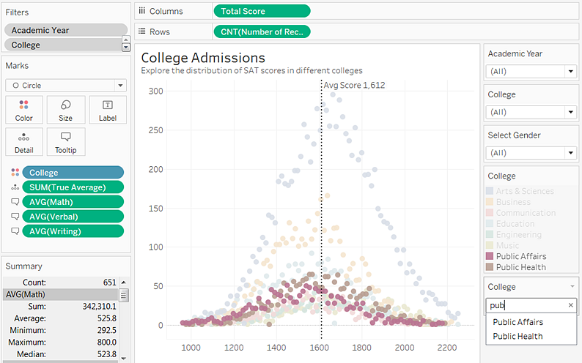

Note that filtering is not the correct option since that would **REMOVE** the data that doesn't match the filtering criteria.

**Reference**: <https://help.tableau.com/current/pro/desktop/en-us/actions_highlight_highlighter.htm>

Bottom of Form

Top of Form

Question 36: **Correct**

**Are animations enabled by default in Tableau?**

* 

**Yes**

* 

**No**

**(Correct)**

**Explanation**

No,  Animations are not enabled by default in Tableau!

We can animate visualizations to better highlight changing patterns in your data, reveal spikes and outliers, and see how data points cluster and separate.

Animations visually transition between filter, sort, and zoom settings, different pages, and changes to filter, parameter, and set actions. As visualizations animate in response to these changes, viewers can more clearly see how data differs, helping them make better informed decisions.

When you author animations, you can choose between two different styles: **simultaneous or sequential**. Here are examples of each type.

**1) Simultaneous animations**

The default simultaneous animations are faster and work well when showing value changes in simpler charts and dashboards.



**2) Sequential animations**

Sequential animations take more time but make complex changes clearer by presenting them step-by-step.



**To Animate visualizations in a workbook:**

1) Choose Format > Animations.

2) If you want to animate every sheet, under Workbook Default, click On. Then do the following:

For Duration, choose a preset, or specify a custom duration of up to 10 seconds.

For Style, choose Simultaneous to play all animations at once or Sequential to fade out marks, move and sort them, and then fade them in.

3) To override workbook defaults for a particular sheet, change the settings under Selected Sheet.

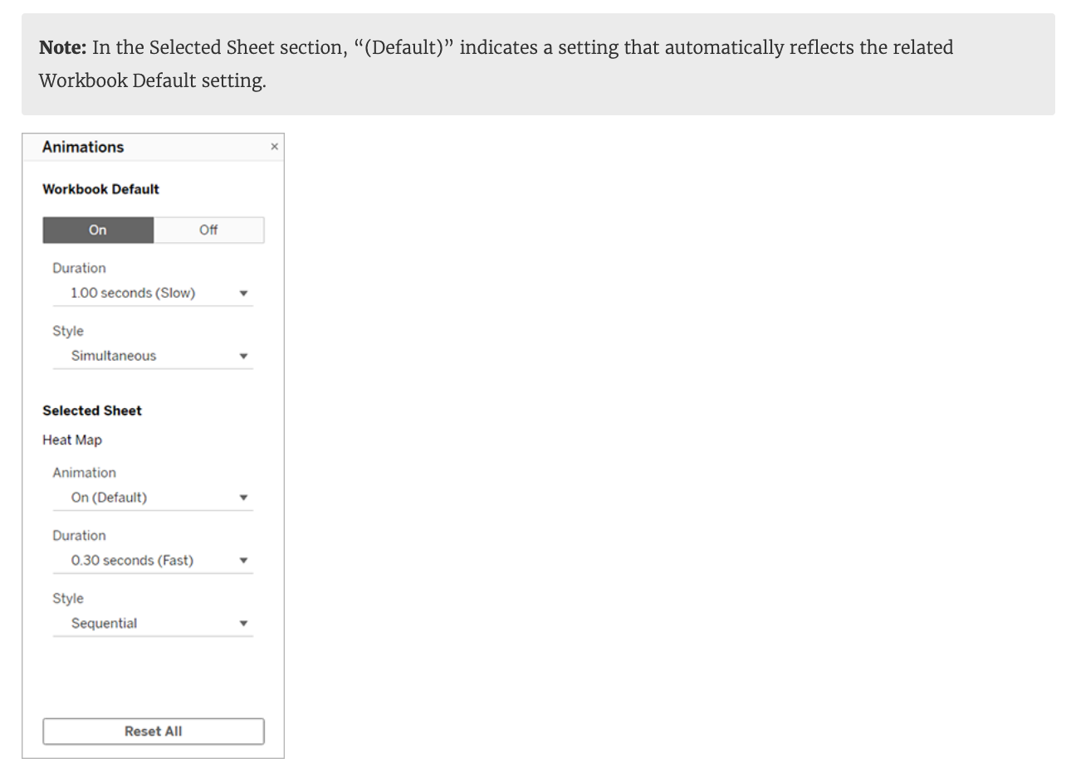

**Reference:** <https://help.tableau.com/current/pro/desktop/en-us/formatting_animations.htm>

Bottom of Form

Top of Form

Question 37: **Incorrect**

**Which of the following are valid way(s) to make either of Rows or Columns Bold without affecting the other?**

* 

**Right click on Rows or Columns, and choose format. In the Font option click on Bold.**

**(Correct)**

* 

**Choose Format from the Menu bar, select Row or Column, and then select Bold under the header option**

**(Correct)**

* 

**Select Text Label on the Marks Card, choose Rows or Columns, and then select Bold.**

**(Incorrect)**

* 

**Choose Format then Font from the Menu bar, and select Bold under the Header option**

**Explanation**

**1) Right click on Rows or Columns, and choose format. In the Font option click on Bold. (CORRECT) - this will modify only the selected axis (row or column)**

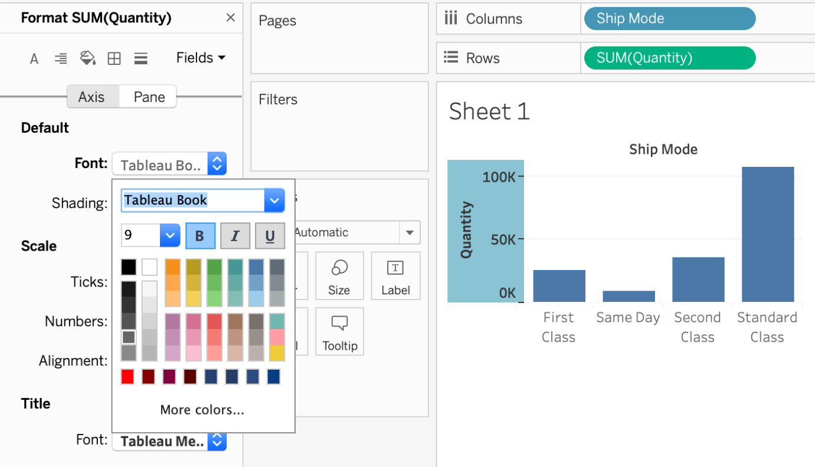

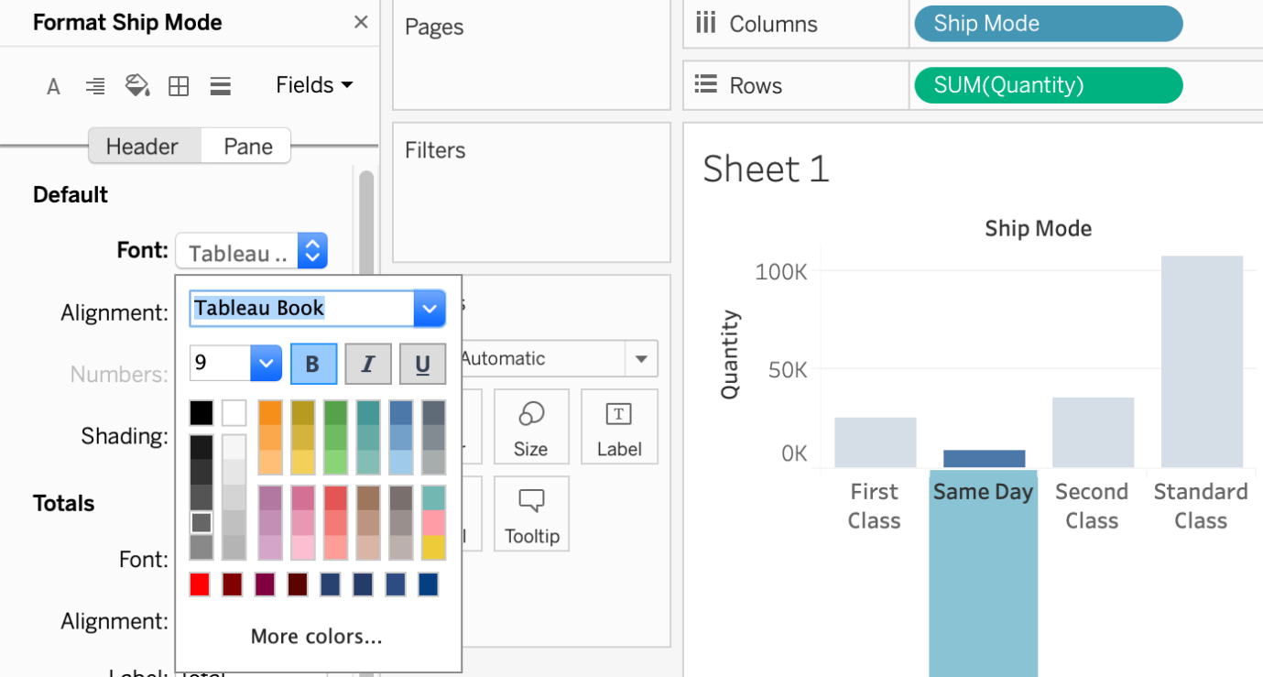

**2) Choose Format then Font from the Menu bar, and select Bold under the Header option (INCORRECT) - this modifies both rows and columns at the same time**

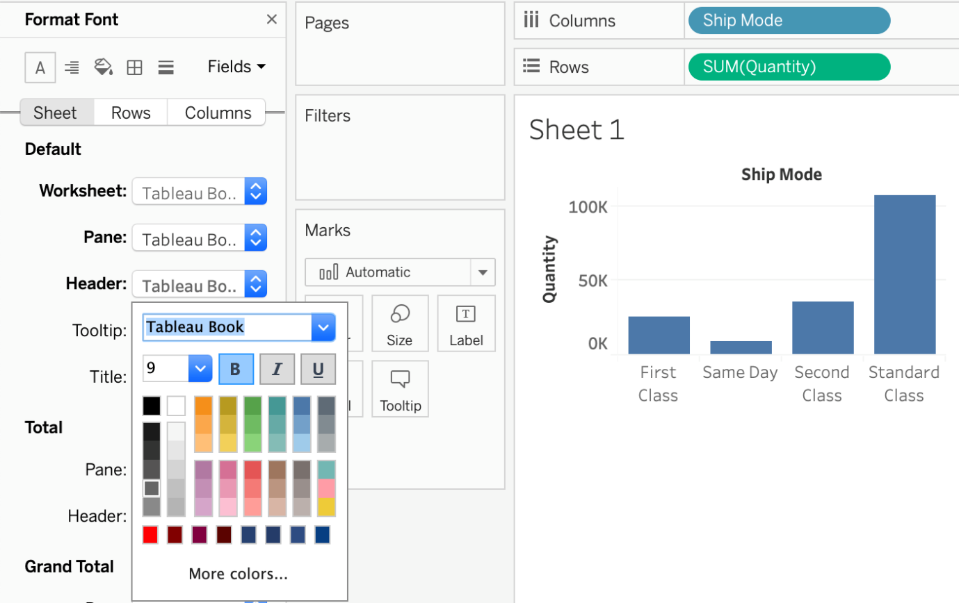

**3) Choose Format from the Menu bar, select Row or Column, and then select Bold under the header option (CORRECT) -  this will modify only the selected axis (row or column)**

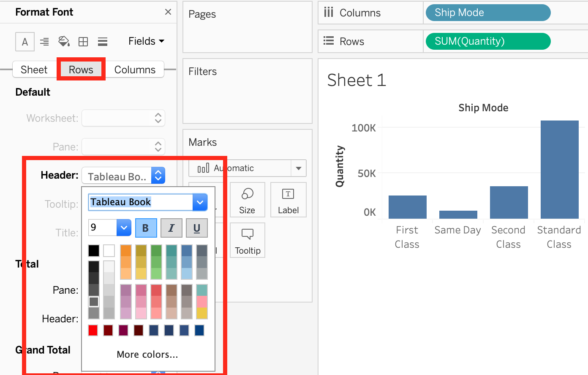

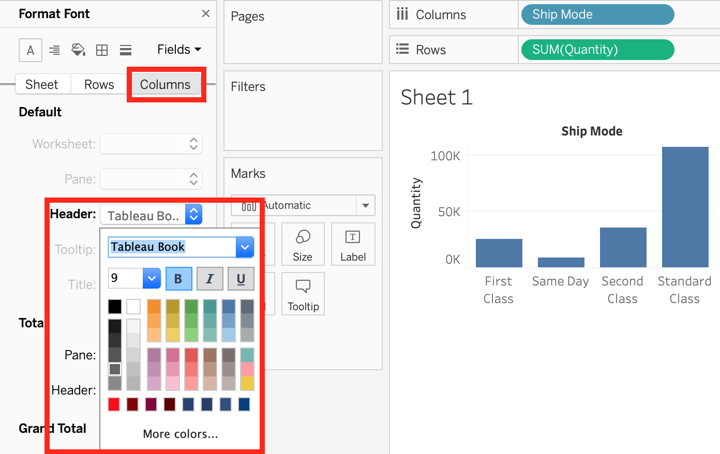

**4) Select Text Label on the Marks Card, choose Rows or Columns, and then select Bold. (INCORRECT) - no such option exists**

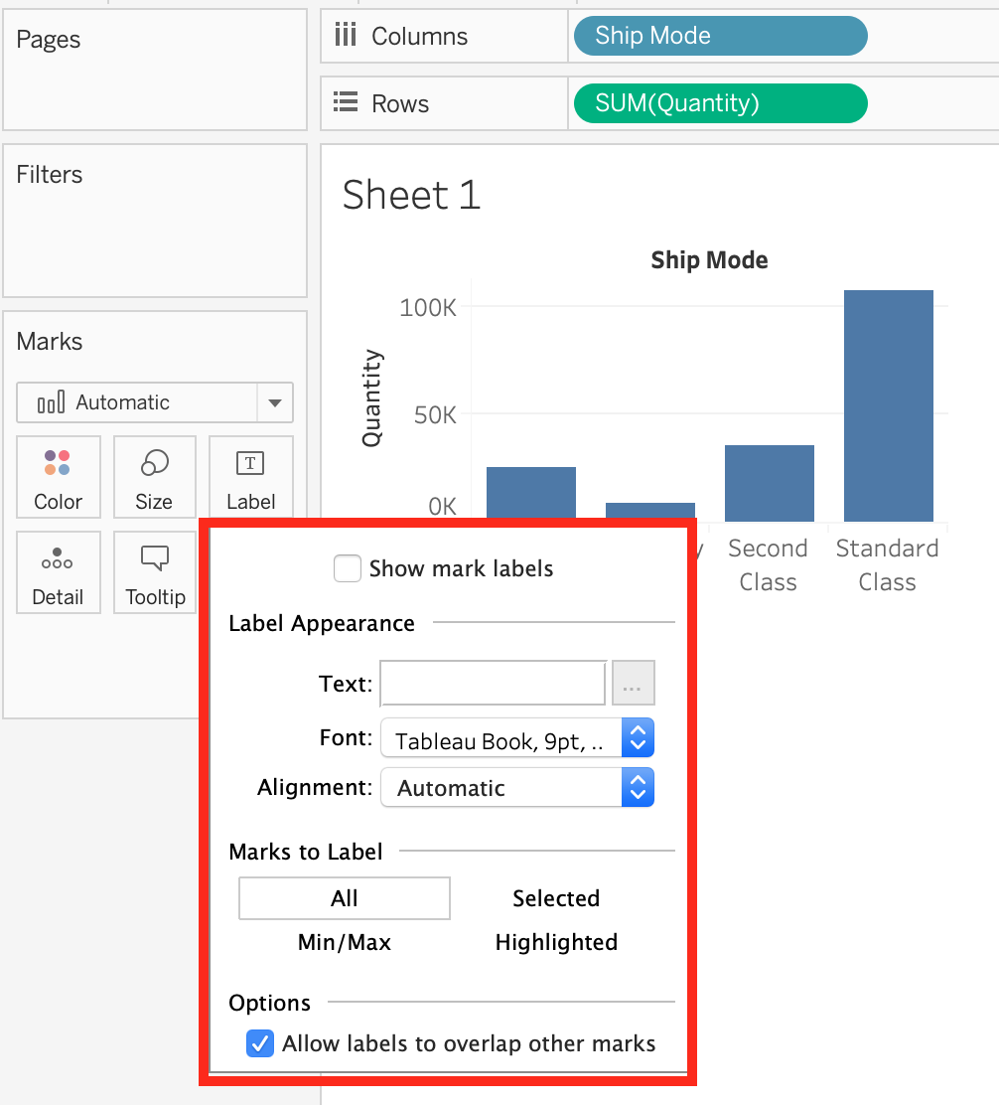

Bottom of Form

Top of Form

Question 38: **Incorrect**

**Suppose you create a bar chart by dragging a dimension to the Column shelf and a measure to the Rows shelf. Which of the following would create a stacked bar chart?**

* 

**By dragging another dimension to the Rows shelf**

* 

**By dragging another measure to the Columns shelf**

* 

**By dragging another measure to Color on the Marks card**

**(Incorrect)**

* 

**By dragging another dimension to Color on the Marks card**

**(Correct)**

**Explanation**

Very important question for the exam and appears quite a lot too.

**The correct answer is -**By dragging another dimension to Color on the Marks card.

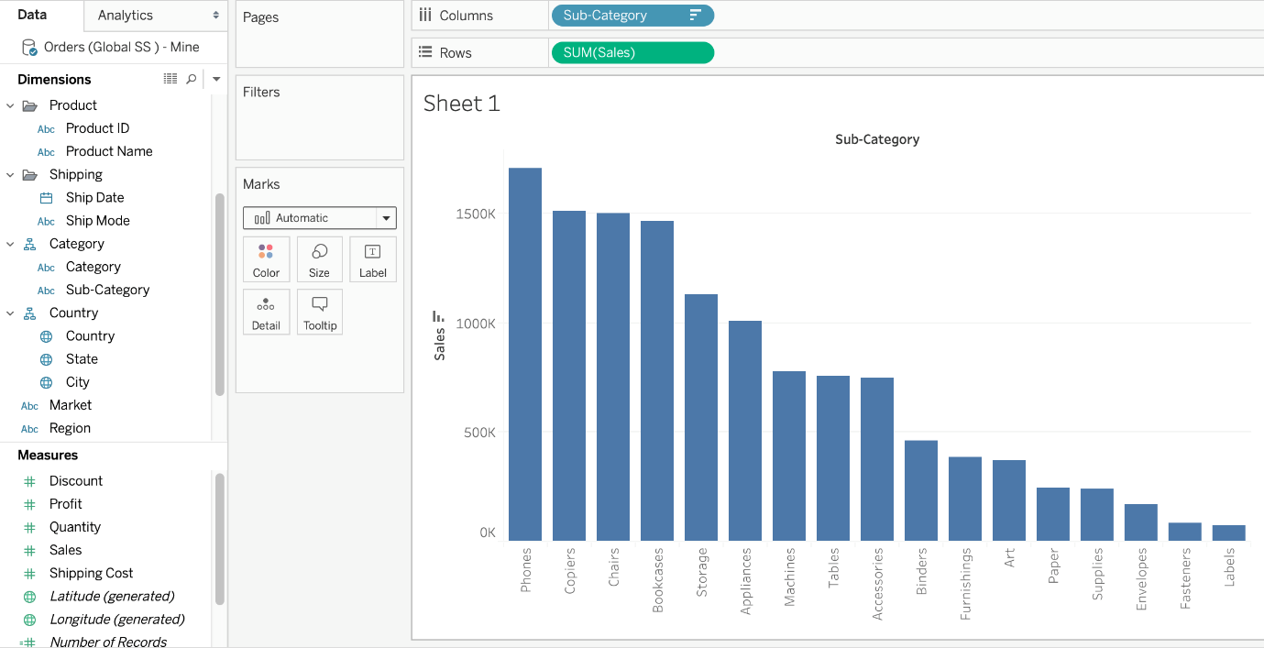

This is what the question says we have already created. Now to convert this into a Stacked bar chart, we will drop another dimension on Color in the Marks card.

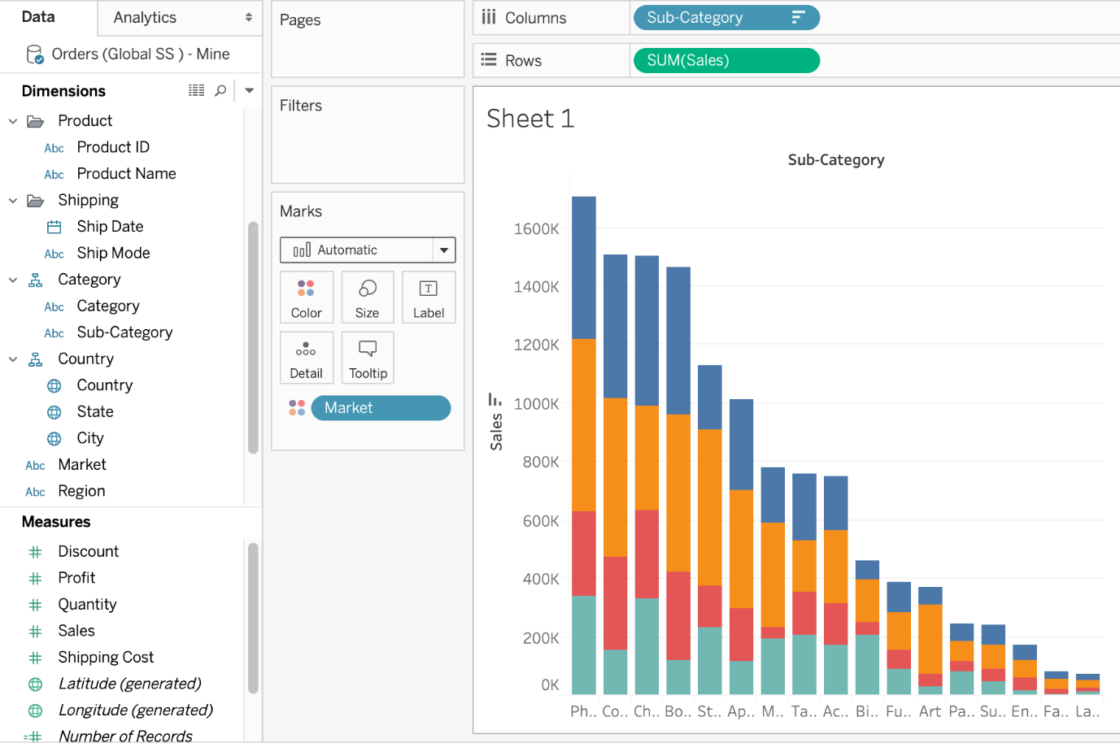

The rest won't create stacked bar charts, and hence are incorrect choices. The best way to answer such questions on the real exam is to quickly do what the options say and see if they satisfy the requirements in the question.

Bottom of Form

Top of Form

Question 39: **Correct**

**Which one of the following is a dimension?**

* 

**Measure Names**

**(Correct)**

* 

**Longitude**

* 

**Latitude**

* 

**Number of records**

**Explanation**

Measure Names is a **dimension**. Latitude, Longitude, and Number of records are all **measures**.

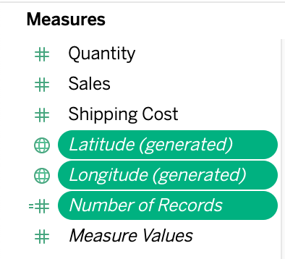

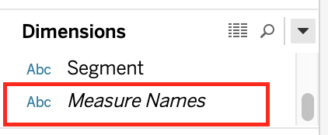

**Reference:** <https://help.tableau.com/current/pro/desktop/en-us/datafields_understanddatawindow.htm>

Bottom of Form

Top of Form

Question 40: **Correct**

**If you see a Blue field, generally it will add _____________ to the view**

* 

**axis**

* 

**headers**

**(Correct)**

* 

**none**

* 

**both**

**Explanation**

**Important question!**

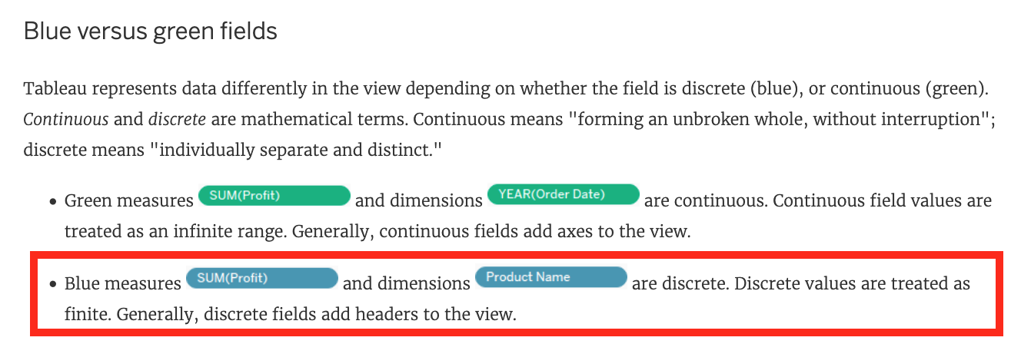

**Reference:**<https://help.tableau.com/current/pro/desktop/en-us/datafields_typesandroles.htm>

Bottom of Form

Top of Form

Question 41: **Correct**

**If you are working with a huge dataset, which of the following are strong reasons to use a context filter?**

* 

**To make the context filter a dependent filter**

* 

**To include only the data of interest**

**(Correct)**

* 

**To help clean the data**

* 

**Improve query performance**

**(Correct)**

**Explanation**

By default, all filters that you set in Tableau are computed **independently**. That is, each filter accesses all rows in your data source without regard to other filters. However, you can set one or more categorical filters as context filters for the view. **You can think of a context filter as being an independent filter (Option stating - To create a dependent filter eliminated here).** Any other filters that you set are defined as dependent filters because they process only the data that passes through the context filter.

**You may create a context filter to:**

**1) Improve performance –**If you set a lot of filters or have a large data source, the queries can be slow. You can set one or more context filters to improve performance.

**2) Create a dependent numerical or top N filter –**You can set a context filter to include only the data of interest, and then set a numerical or a top N filter.

For example, suppose you’re in charge of breakfast products for a large grocery chain. Your task is to find the top 10 breakfast products by profitability for all stores. If the data source is **very large**, you can set a context filter to include **only** breakfast products. Then you can create a top 10 filter by profit as a dependent filter, which would process only the data that passes through the context filter.



**Reference:** <https://help.tableau.com/current/pro/desktop/en-us/filtering_context.htm>

Bottom of Form

Top of Form

Question 42: **Correct**

**While borders and background colors let you visually highlight** **items on a dashboard, _________ lets you precisely space items.**

* 

**spacing**

* 

**tiling**

* 

**margining**

* 

**padding**

**(Correct)**

**Explanation**

**Padding** lets you precisely space items on dashboard, while borders and background colors let you visually highlight them. **Inner padding** sets the spacing between item contents and the perimeter of the border and background color;**outer padding** provides additional spacing beyond the border and background color.

**Reference:**<https://help.tableau.com/current/pro/desktop/en-us/dashboards_organize_floatingandtiled.htm>

Bottom of Form

Top of Form

Question 43: **Correct**

**Creating a scatter plot requires a minimum of how many measures?**

* 

**3**

* 

**1**

* 

**2**

**(Correct)**

* 

**4**

**Explanation**

We can use scatter plots to visualize **relationships** between numerical variables!

In Tableau, you create a scatter plot by placing at least one measure on the Columns shelf and at least one measure on the Rows shelf **(Total 2 minimum)**. If these shelves contain both dimensions and measures, Tableau places the measures as the innermost fields, which means that measures are always to the right of any dimensions that you have also placed on these shelves. The word "innermost" in this case refers to the table structure.

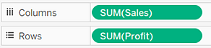 **( Simple Scatter Plot)**

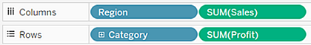 **(Matrix of Scatter Plots)**

A scatter plot can use several mark types. By default, Tableau uses the shape mark type. Depending on your data, you might want to use another mark type, such as a circle or a square. For more information, see [Change the Type of Mark in the View](https://help.tableau.com/current/pro/desktop/en-us/viewparts_marks_marktypes.htm).

**To create a scatter plot, follow the steps below:**



**Reference:** <https://help.tableau.com/current/pro/desktop/en-us/buildexamples_scatter.htm>

Bottom of Form

Top of Form

Question 44: **Correct**

**Which of the following are valid Layout Container types when using Dashboards in Tableau?**

* 

**Split Container**

* 

**Diagonal Container**

* 

**Horizontal Container**

**(Correct)**

* 

**Vertical Container**

**(Correct)**

**Explanation**

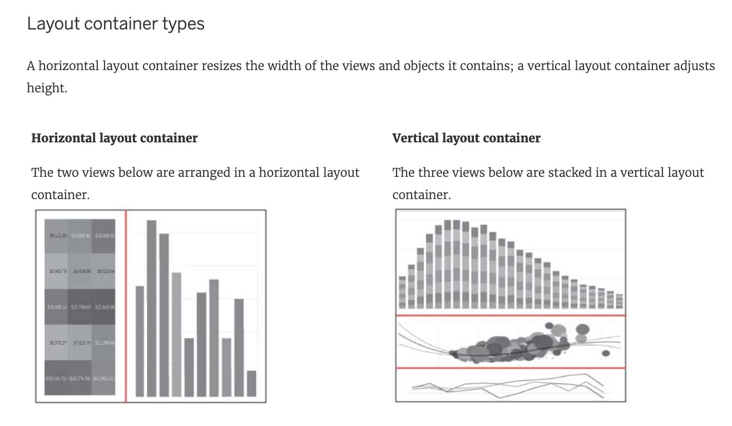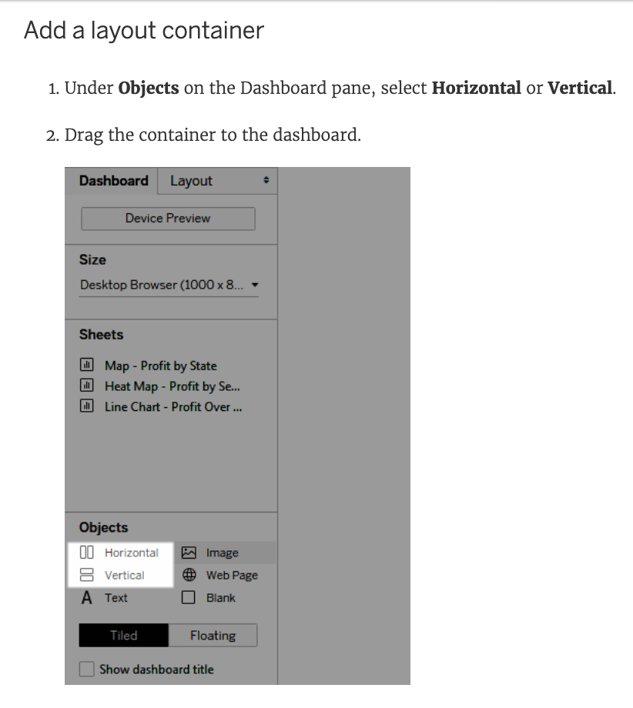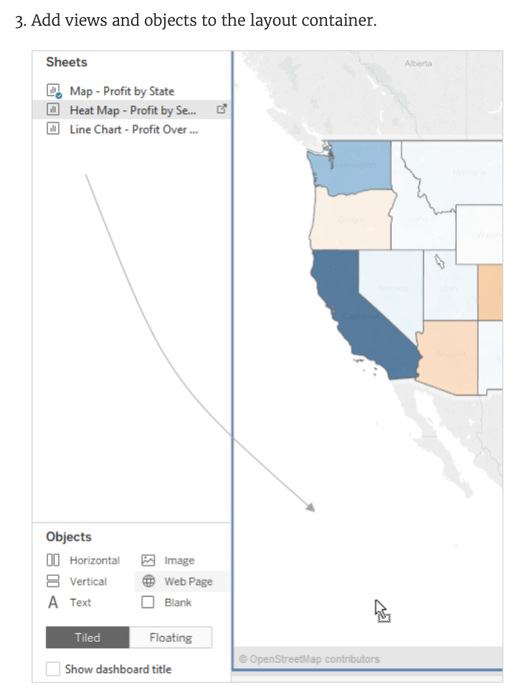

**Reference:**<https://help.tableau.com/current/pro/desktop/en-us/dashboards_organize_floatingandtiled.htm>

Bottom of Form

Top of Form

Question 45: **Incorrect**

**Which of the following are valid ways to export a dashboard with multiple visualisations as an image?**

* 

**Click on Dashboard in the Menu bar followed by Copy Image**

**(Correct)**

* 

**Click on Worksheet in the Menu bar followed by Export, then choose Image**

**(Incorrect)**

* 

**Right click on the dashboard, and choose Copy, then image.**

**(Incorrect)**

* 

**Using the floating export worksheet option on the Dashboard**

**Explanation**

**Only 1 option is correct -**

Click on Dashboard in the Menu bar followed by Copy Image

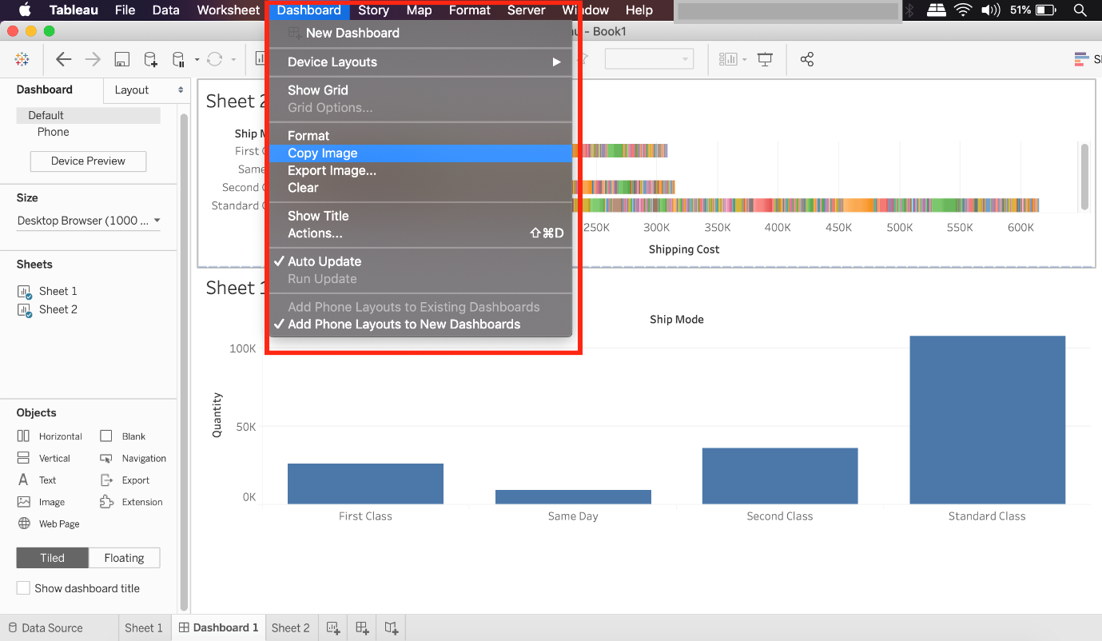

**Right click on the dashboard, and choose Copy, then image -**Try doing this, you will end up copying just one of the worksheets not the entire dashboard

**Click on Worksheet in the Menu bar followed by Export, then choose Image -**Again, try doing this. You will end up copying just one of the worksheets not the entire dashboard

**Using the floating export worksheet option on the Dashboard -** No such option exists

Bottom of Form